City of
Hidden Hills

2021-2029
Housing Element

DRAFT

November 2021

Contents
I. Introduction I-1
A. Purpose of the Housing Element I-1
B. Public Participation I-2
C. Consistency with Other Elements of the General Plan I-2
II. Housing Needs Assessment II-1
A. Population Characteristics II-1
1. Population Growth Trends II-1
2. Age and Gender II-1
B. Household Characteristics II-2
1. Household Composition and Size II-2
2. Housing Tenure and Vacancy II-3
3. Overcrowding II-3
4. Overpayment II-4
C. Employment II-5
1. Current Employment II-5
D. Housing Stock Characteristics II-6
1. Housing Type II-7
2. Housing Age and Condition II-7
3. Housing Cost II-8
E. Special Needs II-11
1. Persons with Disabilities II-11
2. Elderly II-14
3. Large Households II-15
4. Female-Headed Households II-15
5. Farm Workers II-16
6. Homeless Persons II-17
F. Assisted Housing at Risk of Conversion II-18
G. Projected Housing Needs 2021-2029 II-18
H. Fair Housing Assessment II-19
III. Resources and Opportunities III-1
A. Land Resources III-1
B. Financial and Administrative Resources III-2
C. Energy Conservation Opportunities III-2
IV. Constraints IV-1
A. Governmental Constraints IV-1
1. Land Use Plans and Regulations IV-1
2. Development Processing Procedures IV-8
3. Development Fees and Improvement Requirements IV-8
B. Non-Governmental Constraints IV-10
1. Private Codes, Covenants, and Restrictions (CC&Rs) IV-10
2. Environmental Constraints IV-11
3. Infrastructure Constraints IV-11
4. Land Costs IV-12
5. Construction Costs IV-12
6. Cost and Availability of Financing IV-12
V. Housing Plan V-1
A. Goals, Policies and Implementation Programs V-1
B. Quantified Objectives V-7

Appendices
Appendix A Evaluation of the Prior Housing Element
Appendix B Residential Land Inventory
Appendix C Public Participation Summary

List of Tables
Table II-1 Population Trends, 2000-2020 - Hidden Hills vs. SCAG Region II-1
Table II-2 Population by Age and Gender – Hidden Hills II-2
Table II-3 Household Size by Tenure – Hidden Hills II-2
Table II-4 Household Tenure – Hidden Hills vs. SCAG Region II-3
Table II-5 Overcrowding – Hidden Hills vs. SCAG Region II-4
Table II-6 Overpayment by Income Category – Hidden Hills II-4
Table II-7 Extremely-Low-Income Households by Ethnicity and Tenure – Hidden Hills II-5
Table II-8 Employment by Industry – Hidden Hills II-6
Table II-9 Employment by Occupation – Hidden Hills vs. SCAG Region II-6
Table II-10 Housing Units by Type – Hidden Hills vs. SCAG Region II-7
Table II-11 Housing Units by Year Built – Hidden Hills vs. SCAG Region II-8
Table II-12 Income Categories and Affordable Housing Costs – Los Angeles County II-9
Table II-13 Existing Home Median Sales Prices– Hidden Hills vs. SCAG Region II-9
Table II-14 Monthly Mortgage Costs – Hidden Hills vs. SCAG Region II-10
Table II-15 Percentage of Income Spent on Rent – Hidden Hills II-10
Table II-16 Rental Cost by Income Category – Hidden Hills II-11
Table II-17 Disabilities by Type – Hidden Hills II-12
Table II-18 Disabilities by Type for Seniors Age 65+ - Hidden Hills vs. SCAG Region II-12
Table II-19 Persons with Disabilities by Employment Status – Hidden Hills II-13
Table II-20 Elderly Households by Income and Tenure – Hidden Hills II-14
Table II-21 Household Size by Tenure II-15
Table II-22 Female-Headed Households – Hidden Hills II-16
Table II-23 Households by Poverty Status – Hidden Hills II-16
Table II-24 Agricultural Employment – Hidden Hills II-17
Table II-25 2021-2029 Regional Housing Needs – Hidden Hills II-19
Table III-1 Land Inventory Summary III-1
Table IV-1 Residential Land Use Categories – Hidden Hills General Plan IV-1
Table IV-2 Residential Zones IV-2
Table IV-3 Permitted Residential Development by Zone IV-3
Table IV-4 Development Fee Summary IV-9
Table V-1 Quantified Objectives (2021-2029) V-7

This page intentionally left blank.

Introduction
State law requires the preparation of a Housing Element as part of a jurisdiction's General Plan (Government Code §65302(c)). The Element is to consist of an identification and analysis of existing and projected housing needs, and a statement of goals, policies, quantified objectives and scheduled programs for the preservation, improvement and development of housing. It is also required to identify adequate sites for housing and to make adequate provision for the existing and projected needs of all economic segments of the community (§65583).
Guidelines adopted by the Department of Housing and Community Development (HCD) are also to be considered in the preparation of the Element (§65585). Periodic review of the Element is required to evaluate (1) the appropriateness of its goals, objectives and policies in contributing to the attainment of the state housing goals, (2) its effectiveness in attaining the City's housing goals and objectives and (3) the progress of its implementation (§65588).

Purpose of the Housing Element
State law recognizes the vital role local governments play in the supply and affordability of housing. Each local government in California is required to adopt a comprehensive, long-term General Plan for the physical development of the city or county. The Housing Element is one of the seven mandated elements of the General Plan. Housing Element law, first enacted in 1969, mandates that local governments plan to meet the existing and projected housing needs of all economic segments of the community. The law recognizes that, in order for the private market to adequately address housing needs, local governments must adopt land use plans and regulatory systems that provide opportunities for, and do not unduly constrain, housing development. As a result, housing policy in California rests largely upon the effective implementation of local General Plans and, in particular, local Housing Elements. Housing Element law also requires the California Department of Housing and Community Development (HCD) to review local housing elements for compliance with state law and to report its written findings to the local government.
As mandated by State law, the planning period for this Housing Element extends from 2021 to 2029. This Element identifies strategies and programs that focus on: 1) providing diversity in housing opportunities and 2) maintenance and preservation of the housing stock.
The Housing Element consists of the following major components:
- An analysis of the City’s demographic and housing characteristics and trends (Chapter II);
- An evaluation of land, financial, and administrative resources available to address the City’s housing goals (Chapter III);
- A review of potential constraints, both governmental and non-governmental, to meeting the City’s housing needs (Chapter IV); and
- A Housing Plan for the 2021-2029 planning period, including housing goals, policies and programs (Chapter V).
- A review of the City’s accomplishments and progress in implementing the previous Housing Element (Appendix A).

Public Participation
Section 65583(c)(5) of the Government Code states that “The local government shall make diligent effort to achieve public participation of all the economic segments of the community in the development of the housing element, and the program shall describe this effort.” Public participation played an important role in the formulation and refinement of the City’s housing goals and policies and in the development of a Land Use Plan which determines the extent and density of future residential development in the community.
City residents had several opportunities to recommend strategies, review, and comment on the Housing Element. All meeting notices were posted at four locations within the City, and meeting agendas were posted on the City’s website and cable channel in advance of the meetings. In addition, meeting notices were sent by direct mail to the list of interested parties (see Appendix C). Copies of the draft element were made available for review at City Hall and were posted on the City’s website. Please refer to Appendix C for a complete listing of opportunities for public involvement in the preparation of this Housing Element update, as well as a summary of comments received and how those comments have been addressed.

Consistency with Other Elements of the General Plan
The City’s General Plan sets forth broad policy guidance in the areas of land use, housing, transportation, conservation, open space and recreation, noise and public safety. The various General Plan elements provide a consistent set of policies and programs intended to preserve and enhance the quality of life, while accommodating growth and change in a proactive manner. For example, residential development capacities established in the Land Use Element and constraints to development identified in the Conservation, Public Safety, and Noise Elements are reflected in the Housing Element. This Housing Element builds upon the other General Plan elements and is consistent with the policies and proposals set forth by the Plan. As the General Plan is amended from time to time, the City will review the Housing Element for internal consistency, and make any necessary revisions.
Senate Bill (SB) 1087 of 2005 requires cities to provide a copy of their Housing Elements to local water and sewer providers, and also requires that these agencies provide priority hookups for developments with lower-income housing. The Housing Element will be provided to these agencies immediately upon adoption.

Housing Needs Assessment
This chapter examines general population and household characteristics and trends, such as age, employment, household composition and size, household income, and special needs. Characteristics of the existing housing stock (e.g., number of units and type, tenure, age and condition, costs) are also addressed. Finally, the city’s projected housing growth needs based on the 2021-2029 Regional Housing Needs Assessment (RHNA) are examined.
The Housing Needs Assessment utilizes recent data from the U.S. Census, California Department of Finance (DOF), California Employment Development Department (EDD), Southern California Association of Governments (SCAG), and other relevant sources.

Population Characteristics

Population Growth Trends
The City of Hidden Hills had a net loss of 7 residents during the 20-year period from 2000-2020 (Table II-1). This contrasts dramatically with Los Angeles County, which had an annual growth rate of approximately 0.7% during the same period. As a nearly built-out city, there have been few opportunities for growth in Hidden Hills in recent years.

Population Trends, 2000-2020 - Hidden Hills vs. SCAG Region

Age and Gender
Housing needs are influenced by the age characteristics of the population. Different age groups have different housing needs based on lifestyles, family types, income levels, and housing preference. According to recent Census estimates (Table II-2), the population of Hidden Hills is approximately 49.3% male and 50.7% female. The share of the population of Hidden Hills under 18 years of age is about 27%, which is higher than the regional share of 23%. Hidden Hills's seniors (65 and above) make up 18.5% of the population, which is higher than the regional share of 13%.

Population by Age and Gender – Hidden Hills

Household Characteristics

Household Composition and Size
Household characteristics are important indicators of the type and size of housing needed in a city. The Census defines a “household” as all persons occupying a housing unit, which may include single persons living alone, families related through marriage or blood, or unrelated persons sharing a single unit. Persons in group quarters such as dormitories, retirement or convalescent homes, or other group living situations are included in population totals, but are not considered households.

Household Size by Tenure – Hidden Hills

According to recent Census data (Table II-3), the most commonly occurring household size in Hidden Hills is two people (34%) while the second-most commonly occurring household is of four people (24.8%). Hidden Hills has a lower share of single-person households than the SCAG region overall (13.6% vs. 23.4%) and a lower share of 7+ person households than the SCAG region overall (0.9% vs. 3.1%).

Housing Tenure and Vacancy
Housing tenure (owner vs. renter) is an important indicator of the housing market. Generally, communities should have an adequate supply of units available both for rent and for sale in order to accommodate a range of households with varying incomes, family sizes and composition, and lifestyles. However, in some jurisdictions like Hidden Hills, housing tenure is significantly different than in most areas. Table II-4 provides a comparison of the number of owner-occupied and renter-occupied units in the city compared to the region as a whole. Approximately 97% of homes in Hidden Hills are owner-occupied compared to about 53% for the SCAG region as a whole.

Household Tenure – Hidden Hills vs. SCAG Region

Overcrowding
Overcrowding is often closely related to household income and the cost of housing. The U.S. Census Bureau considers a household to be overcrowded when there is more than one person per room, excluding bathrooms and kitchens, with severe overcrowding when there are more than 1.5 residents per room. Overcrowded households are usually a reflection of the lack of affordable housing. Table II-5 shows recent Census estimates of overcrowding for Hidden Hills and the SCAG region as a whole.

Overcrowding – Hidden Hills vs. SCAG Region

Based on U.S. Census standards, Hidden Hills residents live in significantly less crowded housing conditions than the rest of Los Angeles County. According to recent Census data, only about 1% of owner-occupied units and no rental units in the city were considered overcrowded.

Overpayment
According to state housing policy, overpaying occurs when housing costs exceed 30% of gross household income. Table II-6 displays estimates recent HUD estimates for overpayment in Hidden Hills. This table shows that lower-income households are much more likely to experience overpayment than higher-income households.

Overpayment by Income Category – Hidden Hills

Extremely Low Income Households
State law requires quantification and analysis of existing and projected housing needs of extremely-low-income (ELI) households. Extremely-low-income is defined as households with income less than 30% of area median income. Households with extremely-low-income have a variety of housing situations and needs, such as overpayment and overcrowding. According to recent HUD estimates, approximately 45 extremely-low-income households were reported in Hidden Hills, representing approximately 8.5% of the total households (Table II-7).

Extremely-Low-Income Households by Ethnicity and Tenure – Hidden Hills

The projected housing need for extremely-low-income households is assumed to be 50% of the very-low-income regional housing need of 17 units. As a result, the City has a projected need for 9 extremely-low-income units. The resources and programs to address this need are the same as for low-income housing in general and are discussed throughout the Housing Element, and particularly Chapter V, Housing Plan. The needs of extremely-low-income households overlap extensively with other special needs groups, and further analysis and discussion of resources and programs for extremely-low-income households can also be found in Chapter IV, Constraints, Section A.1.c. Special Needs Housing.

Employment
Employment is an important factor affecting housing needs within a community. Jobs available in each employment sector and the wages for these jobs affect the type of housing residents can afford.

Current Employment
Employment has a significant influence on housing needs. Table II-8 shows recent Census estimates of employment by industry for Hidden Hills residents. The most prevalent industries for City residents were Professional Services, Finance and Education & Social Services.

Employment by Industry – Hidden Hills
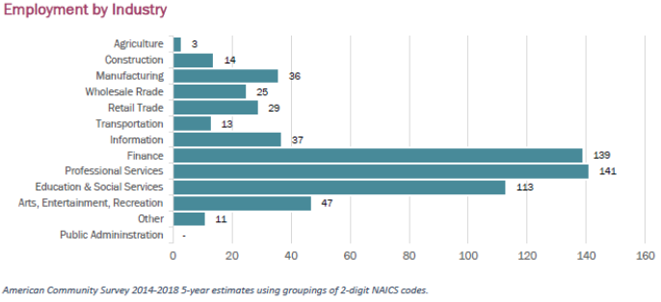

According to recent Census estimates (Table II-9), the most prevalent occupational category in Hidden Hills is Management, in which about 73% of employed residents work.

Employment by Occupation – Hidden Hills vs. SCAG Region

Housing Stock Characteristics
This section reviews the characteristics of the community’s housing stock and helps in identifying and prioritizing needs. The factors evaluated include the number and type of housing units, age and condition, tenure, vacancy, housing costs, affordability, and assisted affordable units at-risk of loss due to conversion to market-rate. A housing unit is defined as a house, apartment, mobile home, or group of rooms, occupied as separate living quarters, or if vacant, intended for occupancy as separate living quarters.

Housing Type
The housing stock in Hidden Hills is comprised entirely of single-family detached homes and accessory dwelling units (ADUs). Table II-10 provides recent Department of Finance estimates of housing type for the city compared to the SCAG region as a whole.

Housing Units by Type – Hidden Hills vs. SCAG Region

Housing Age and Condition
Housing age is often an indicator of housing condition. Housing units built prior to 1978 before stringent limits on the amount of lead in paint were imposed, may have interior or exterior building components coated with lead-based paint. Housing units built before 1970 are now more than 50 years old and are likely to need repairs and may have lead-based paint that could become a health hazard. Table II-12 shows the age distribution of the housing stock in Hidden Hills compared to the SCAG region as a whole according to recent Census estimates.

Housing Units by Year Built – Hidden Hills vs. SCAG Region

This table shows that over half of all housing units in Hidden Hills were constructed prior to 1970. Due to the high housing values and household incomes in Hidden Hills, few properties fall into disrepair, and therefore the need for public assistance with maintenance and rehabilitation is considered to be very low.

Housing Cost

Housing Affordability Criteria
State law establishes five income categories for purposes of housing programs based on the area (i.e., county) median income (“AMI”): extremely-low (30% or less of AMI), very-low (31-50% of AMI), low (51-80% of AMI), moderate (81-120% of AMI) and above moderate (over 120% of AMI). Housing affordability is based on the relationship between household income and housing expenses. According to HUD and the California Department of Housing and Community Development, housing is considered “affordable” if the monthly payment is no more than 30% of a household’s gross income. In some areas, these income limits may be increased to adjust for high housing costs.
Table II-13 shows affordable rent levels and estimated affordable purchase prices for housing in Los Angeles County in 2021 by income category. Based on State standards, the maximum affordable monthly rent for extremely-low-income households is $886, while the maximum affordable rent for very-low-income households is $1,478. The maximum affordable rent for low-income households is $2,365, while the maximum for moderate-income households is $2,400.
Maximum purchase prices are more difficult to determine due to variations in mortgage interest rates and qualifying procedures, down payments, special tax assessments, homeowner association fees, property insurance rates, etc. With this caveat, the maximum home purchase prices by income category shown in Table II-13 have been estimated based on typical conditions.

Income Categories and Affordable Housing Costs –
Los Angeles County
Income Category | Income Limits | Affordable Rent | Affordable Price (est.)
Extremely Low (<30%) | $35,450 | $886 | *
Very Low (31-50%) | $59,100 | $1,478 | *
Low (51-80%) | $94,600 | $2,365 | *
Moderate (81-120%) | $96,000 | $2,400 | $375,000
Above moderate (120%+) | >$96,000 | >$2,400 | >$375,000
Assumptions:
-Based on a family of 4 and 2021 State income limits
-30% of gross income for rent or PITI
-10% down payment, 3.75% interest, 1.25% taxes & insurance, $350 HOA dues
Source: Cal. HCD; JHD Planning LLC

For-Sale Housing
Hidden Hills is a high-end luxury market with no for-sale housing available in the affordable price categories. 2018 median home sales prices in Hidden Hills were $3.5 million (Table II-13) and about 85% of monthly mortgage costs were over $4,000 per month (Table II-14).

Existing Home Median Sales Prices–
Hidden Hills vs. SCAG Region

Monthly Mortgage Costs –
Hidden Hills vs. SCAG Region

Rental Housing
As noted previously (Table II-10, page II-7), there are no multi-family units in Hidden Hills. Only a small number of single-family homes are rented, and few are expected to be available for rent at any given time. Given the rural, single-family nature of the community it is clear that lower- and moderate-income households have a difficult time finding housing without overpaying, and the most likely option for lower-income households wishing to rent in Hidden Hills would be ADUs. Recent data regarding rental units in Hidden Hills are shown in Table II-15 and Table II-16.

Percentage of Income Spent on Rent –
Hidden Hills

Rental Cost by Income Category –
Hidden Hills

Special Needs
Certain groups have greater difficulty in finding decent, affordable housing due to special circumstances such as employment and income, family characteristics, disability, or other conditions. State Housing Element law defines “special needs” groups to include persons with disabilities, the elderly, large households, female-headed households with children, homeless people, and farm workers. This section contains a discussion of the housing needs facing each of these groups.

Persons with Disabilities
Housing opportunities for persons with disabilities can be maximized through universal design features such as widened doorways, ramps, lowered countertops, single-level units and ground floor units. In Hidden Hills, the most commonly occurring disabilities were hearing, independent living, cognitive and ambulatory (Table II-17), while among seniors 65 and older ambulatory disabilities were experienced by about 17% of Hidden Hills's seniors (Table II-18). About 43% of Hidden Hills residents with a disability were in the labor force (Table II-19).

Disabilities by Type – Hidden Hills

Disabilities by Type for Seniors Age 65+ - Hidden Hills vs. SCAG Region

Persons with Disabilities by Employment Status – Hidden Hills

Developmental Disabilities
As defined by federal law, “developmental disability” means a severe, chronic disability of an individual that:
- Is attributable to a mental or physical impairment or combination of mental and physical impairments;
- Is manifested before the individual attains age 22;
- Is likely to continue indefinitely;
- Results in substantial functional limitations in three or more of the following areas of major life activity: a) self-care; b) receptive and expressive language; c) learning; d) mobility; e) self-direction; f) capacity for independent living; or g) economic self-sufficiency;
- Reflects the individual’s need for a combination and sequence of special, interdisciplinary, or generic services, individualized supports, or other forms of assistance that are of lifelong or extended duration and are individually planned and coordinated.
The Census Bureau does not record developmental disabilities. According to the U.S. Administration on Developmental Disabilities, an accepted estimate of the percentage of the population that can be defined as developmentally disabled is 1.5 percent. Many developmentally disabled persons can live and work independently within a conventional housing environment. More severely disabled individuals require a group living environment where supervision is provided. The most severely affected individuals may require an institutional environment where medical attention and physical therapy are provided. Because developmental disabilities exist before adulthood, the first issue in supportive housing for the developmentally disabled is the transition from the person’s living situation as a child to an appropriate level of independence as an adult.
The California Department of Developmental Services (DDS) provides community-based services to persons with developmental disabilities and their families through a statewide system of 21 regional centers, four developmental centers, and two community-based facilities. Hidden Hills is served by the North Los Angeles County Regional Center (NLACRC) in Van Nuys. Any resident who has a developmental disability that originated before age 18 is eligible for services. Services are offered to people with developmental disabilities based on Individual Program Plans and may include: Adult day programs; advocacy; assessment/consultation; behavior management programs; diagnosis and evaluation; independent living services; infant development programs; information and referrals; mobility training; prenatal diagnosis; residential care; respite care; physical and occupational therapy; transportation; consumer, family vendor training; and vocational training. NLACRC also coordinates the State-mandated Early Start program, which provides services for children under age three who have or are at substantial risk of having a developmental disability. According to recent DDS data there were 143 developmental disability clients being served in zip code 91302; however, this zip code includes areas outside of the City of Hidden Hills.
In addition to the services provided by NLACRC, City housing programs that respond to the needs of persons with developmental disabilities include 1d (Emergency Shelters and Transitional/Supportive Housing) and 3a (Section 8 Rental Assistance).

Elderly
Federal housing data define a household type as 'elderly family' if it consists of two persons with either or both age 62 or over. According to recent HUD data, about 13.7% of Hidden Hills' elderly households earn less than 30% of the surrounding area income compared to 24.2% in the SCAG region, and 27.5% earn less than 50% of the surrounding area income compared to 30.9% in the SCAG region (Table II-20). All elderly renter households had incomes above the median.

Elderly Households by Income and Tenure – Hidden Hills

Large Households
Household size is an indicator of need for large units. Large households are defined as those with five or more members. Among Hidden Hills owner households, about 87% had less than five members and no renter households had five or more members (Table II-21). Considering the nature of the housing stock in Hidden Hills (predominantly larger single-family homes) this data suggests that there is not likely to be a shortage of large homes compared to the number of larger households. This conclusion is also supported by the very low incidence of overcrowding (see Table II-5).

Household Size by Tenure
Householder Age | Owner |  | Renter
Householder Age | Households | % | Households | %
1 person | 74 | 14.1% | 0 | 0.0%
2 persons | 182 | 34.7% | 3 | 15.8%
3 persons | 81 | 15.4% | 3 | 15.8%
4 persons | 122 | 23.2% | 13 | 68.4%
5 persons | 50 | 9.5% | 0 | 0.0%
6 persons | 11 | 2.1% | 0 | 0.0%
7 persons or more | 5 | 1.0% | 0 | 0.0%
Total Households | 525 | 100% | 19 | 100%
Source: SCAG; U.S. Census 2014-2018 ACS

Female-Headed Households
Recent Census estimates (Table II-22) reported that about 7.5% of households in Hidden Hills are female-headed (compared to 14.3% in the SCAG region), 3.1% are female-headed and with children (compared to 6.6% in the SCAG region), and none are female-headed and with children under 6 (compared to 1.0% in the SCAG region). In many areas, female-headed households have a disproportionately high housing cost burden.
Recent Census estimates reported that approximately 1.7 percent of Hidden Hills's households are experiencing poverty, compared to 7.9 percent of households in the SCAG region (Table II-23) No female-headed households in Hidden Hills were reported as below the poverty line.

Female-Headed Households – Hidden Hills

Households by Poverty Status – Hidden Hills

Farm Workers
Farm worker households are considered a special needs group due to their transient nature and the lower incomes typically earned by these households. Migrant workers, and their places of residence, are generally located in close proximity to agricultural areas providing employment. Although agriculture is a major industry in some portions of Los Angeles County, no significant agricultural production is found in Hidden Hills or the immediately surrounding communities. Recent Census estimates (Table II-24) reported no jobs in farming, fishing and forestry occupations in Hidden Hills and three persons employed in the agriculture, forestry, fishing and hunting industries. Therefore, farm worker housing is not considered to be an issue for this jurisdiction. Zoning for employee housing is addressed in the analysis of City regulations regarding housing for persons with special needs in Chapter IV – Constraints.

Agricultural Employment – Hidden Hills

Homeless Persons
The U.S. Department of Housing and Urban Development (HUD) defines the term “homeless” as the state of a person who lacks a fixed, regular, and adequate night-time residence, or a person who has a primary night time residency that is:
- A supervised publicly or privately operated shelter designed to provide temporary living accommodations;
- An institution that provides a temporary residence for individuals intended to be institutionalized; or
- A public or private place not designed for, or ordinarily used as, a regular sleeping accommodation for human beings.
Although there are myriad causes of homelessness, among the most common are:
- Substance abuse and alcohol
- Domestic violence
- Mental illness
According to the March 2021 Homelessness Statistics by City report published by the Los Angeles Homeless Services Agency (LAHSA), there were no homeless persons reported in the City of Hidden Hills, in which is within the San Fernando Valley Service Planning Area (SPA 2).
State housing law requires that jurisdictions quantify the need for emergency shelters and determine whether existing facilities are adequate to serve the need. If adequate existing facilities are not available, the law requires jurisdictions to identify areas where new facilities are permitted “by-right” (i.e., without requiring discretionary approval such as a use permit), or enter into a multi-party agreement with up to two other jurisdictions to accommodate the need. City regulations for emergency shelters and other facilities serving the homeless are addressed in the analysis housing for persons with special needs in Chapter IV – Constraints.

Assisted Housing at Risk of Conversion
There are no residential units within the City of Hidden Hills that participate in a federal, state or local program that provide some form of assistance, either through financial subsidy or a control measure. Therefore, there are no units at risk of conversion.

Projected Housing Needs 2021-2029
The Regional Housing Needs Assessment (RHNA) is a key tool for local governments to plan for anticipated growth. The RHNA quantifies the anticipated need for housing within each jurisdiction for the 2021 to 2029 period, also referred to as the “6th cycle” in reference to the six RHNA cycles that have occurred since the comprehensive revision of State Housing Element law in 1980. Communities then determine how they will address this need through the process of updating the Housing Elements of their General Plans.
The 2021-2029 RHNA Plan was adopted by the Southern California Association of Governments (SCAG) in March 2021. The need for housing is determined by the forecasted growth in households in a community as well as existing needs such as overpayment and overcrowding. The housing need for new households is adjusted to maintain a desirable level of vacancy to promote housing choice and mobility. An adjustment is also made to account for units expected to be lost due to demolition, natural disaster, or conversion to non-housing uses. Total housing need is then distributed among four income categories on the basis of the county’s income distribution, with adjustments to avoid an over-concentration of lower-income households in any community. Additional detail regarding SCAG’s methodology used to prepare the RHNA can be reviewed on SCAG’s website at https://scag.ca.gov/rhna.
The share of regional housing need assigned to Hidden Hills for the 2021-2029 planning period is 40 units, which is distributed by income category as shown in Table II-25.

2021-2029 Regional Housing Needs – Hidden Hills
Very  Low* | Low | Moderate | Above Moderate | Total
17 | 8 | 9 | 6 | 40
Source: SCAG 2012
* The Extremely-Low need is assumed to be 9 units, or 50% of the Very-Low need per State law.

It should be noted that SCAG did not identify growth needs for the extremely-low-income category in the adopted RHNA. As provided in Assembly Bill (AB) 2634 of 2006, jurisdictions may determine their extremely-low-income need as one-half the need in the very-low-income category.
The inventory of land to accommodate this RHNA allocation is discussed in Chapter IV - Resources and Opportunities.

Fair Housing Assessment
Under State law, “affirmatively furthering fair housing” means “taking meaningful actions, in addition to combating discrimination, that overcome patterns of segregation and foster inclusive communities free from barriers that restrict access to opportunity based on protected characteristics.”

There are three parts to this requirement:

1. Include a Program that Affirmatively Furthers Fair Housing and Promotes Housing Opportunities throughout the Community for Protected Classes.

2. Conduct an Assessment of Fair Housing that includes summary of fair housing issues, an analysis of available federal, state, and local data and local knowledge to identify, and an assessment of the contributing factors for the fair housing issues.

3. Prepare the Housing Element Land Inventory and Identification of Sites through the Lens of Affirmatively Furthering Fair Housing.

In compliance with AB 686, the City has completed the following outreach and analysis.

Outreach

As discussed in Appendix C, the City held several public meetings during the Housing Element update in an effort to include all segments of the community. Each meeting was publicized on the City’s website and meeting notices were also sent to persons and organizations with expertise in affordable housing and supportive services. Interested parties had the opportunity to interact with City staff throughout the Housing Element update process and provide direct feedback regarding fair housing issues. The City also provided opportunities for all interested persons to participate in public meetings remotely, which made it possible for those with disabilities limiting their travel to participate and comment on the Housing Element regardless of their ability to attend the meetings.

Assessment of Fair Housing

The following analysis examines geographic data regarding racial segregation, poverty, persons with disabilities, and areas of opportunity as identified by the TCAC/HCD Opportunity Areas map.

Racial segregation. As seen in Figure II-1, the percentage of non-white population in the city is relatively low compared to many areas of Los Angeles County. There are no block groups where the non-white population is more than 20% of the total.

Poverty. Recent Census estimates regarding poverty status of households in Hidden Hills are shown in Figure II-2. As seen in this map, poverty rates are low, with all census tracts less than 10%, similar to the adjacent jurisdictions.

Persons with disabilities. The incidence of disabilities in Hidden Hills is similar to the adjacent areas to the south and west and somewhat lower that areas to the northeast. As shown in Figure II-3, the percentage of residents reporting a disability is less than 20% in all census tracts in the city.

Access to opportunity. According to the 2020 California Department of Housing and Community Development (HCD) and the California Tax Credit Allocation Committee (TCAC) Opportunity Area Map (Figure II-4), Hidden Hills is entirely within designated “Highest Resource” areas. Highest Resource areas are those with very high index scores for a variety of educational, environmental, and economic indicators. Some of the indicators identified by TCAC include high levels of employment and close proximity to jobs, access to effective educational opportunities for both children and adults, low concentration of poverty, and low levels of environmental pollutants, among others.

Conclusion

This analysis indicates that there is no evidence to suggest that discrimination against racial groups or persons with disabilities is a major issue in Hidden Hills. The primary barrier to fair housing in the city is very high housing cost, which has the effect of limiting access by lower-income households to the high opportunities and resources available in the city. Accessory dwelling units provide opportunities for lower-income persons to find affordable housing in Hidden Hills.

The Housing Plan (Chapter V) includes programs intended to encourage and facilitate multi-family and mixed-use development to accommodate low- and moderate-income housing, and also encourage the provision of accessory dwelling units, which can expand affordable housing opportunities for lower-income persons including care-givers, household employees and others working in service occupations. Program 6 describes actions the City will take to affirmatively further fair housing and address any issues of housing discrimination that may arise.

Racial Characteristics – Hidden Hills
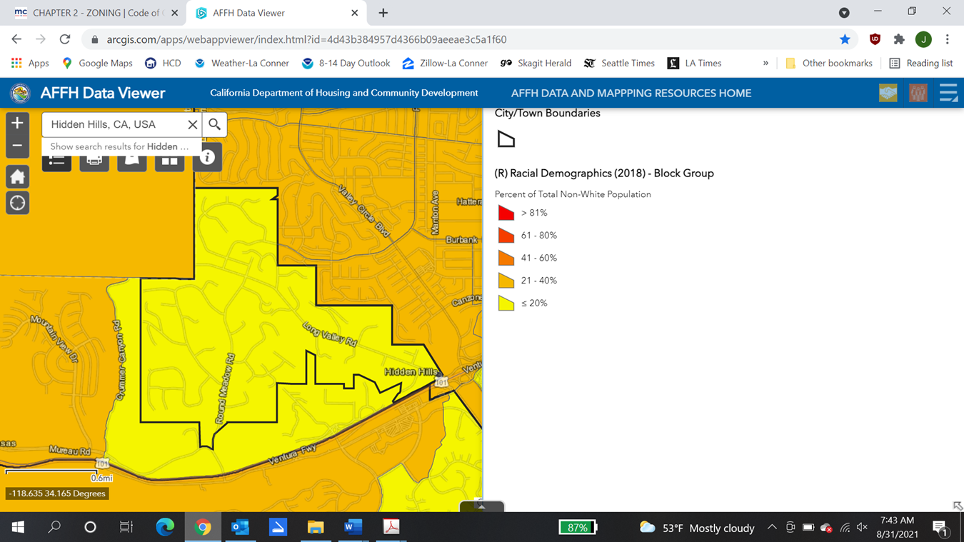
Source: California Department of Housing and Community Development, AFFH Data Viewer, 2021

Poverty Status – Hidden Hills
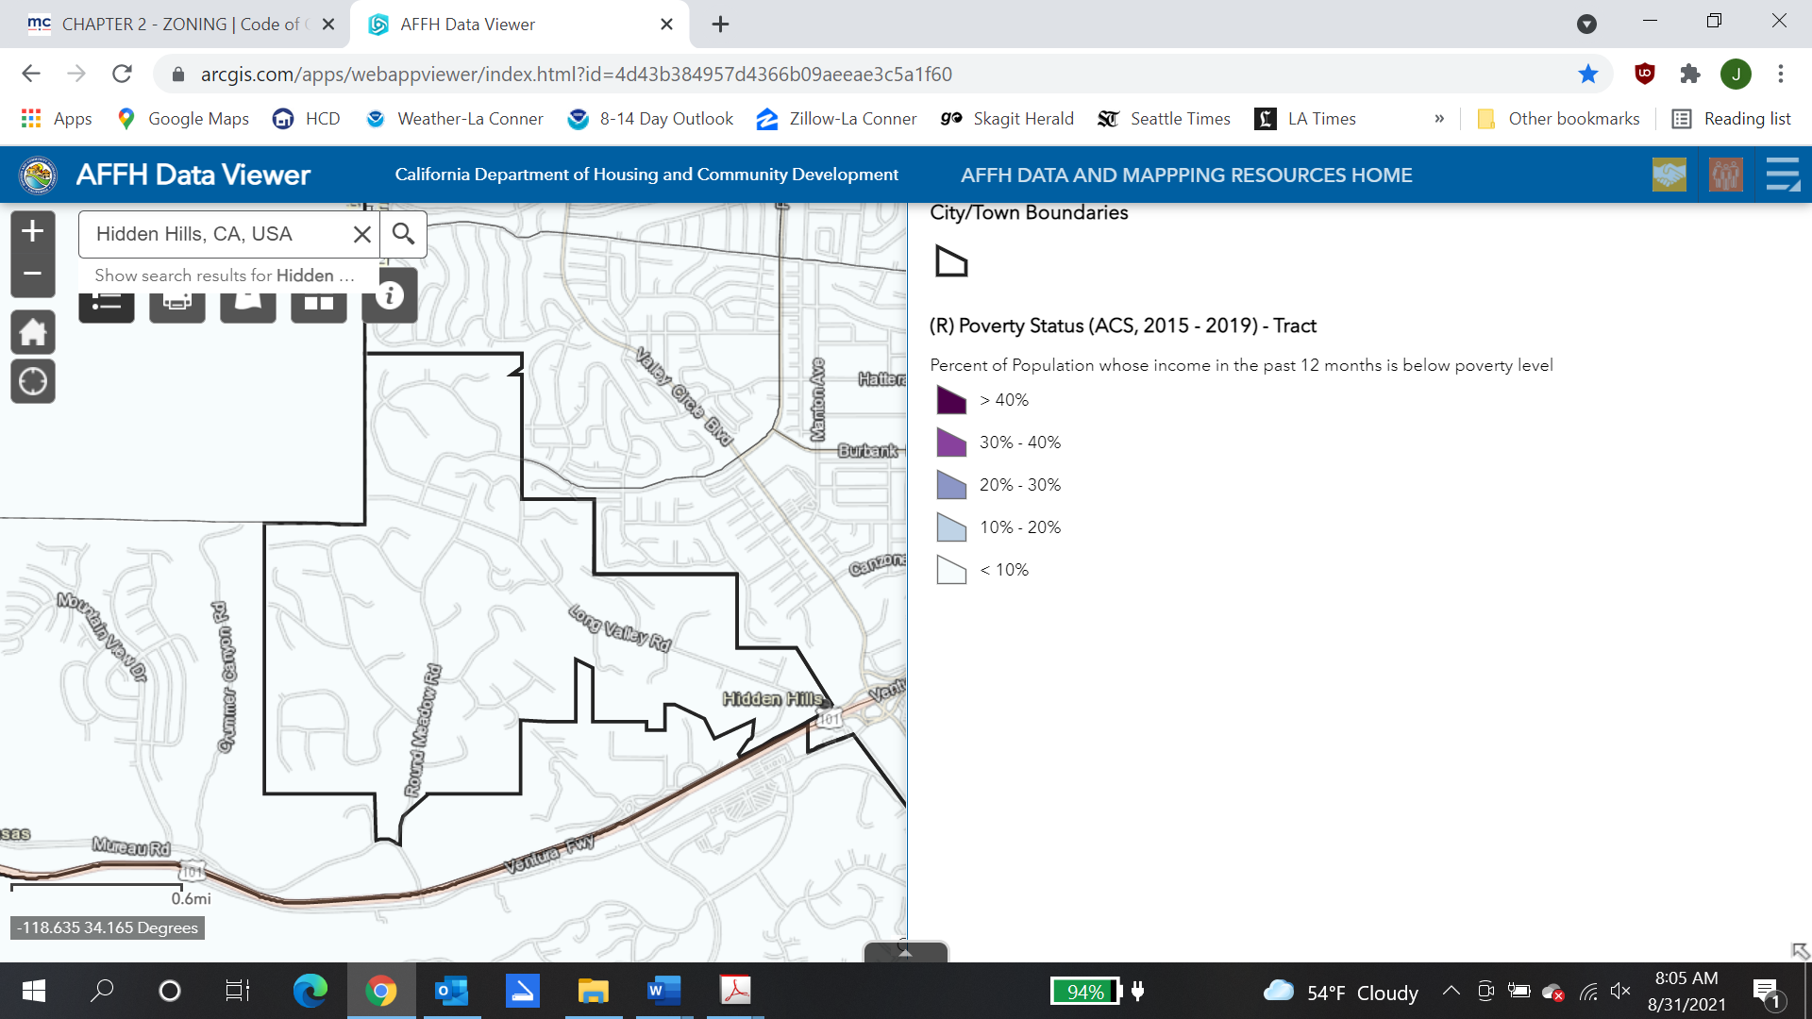
Source: California Department of Housing and Community Development, AFFH Data Viewer, 2021

Population with a Disability – Hidden Hills
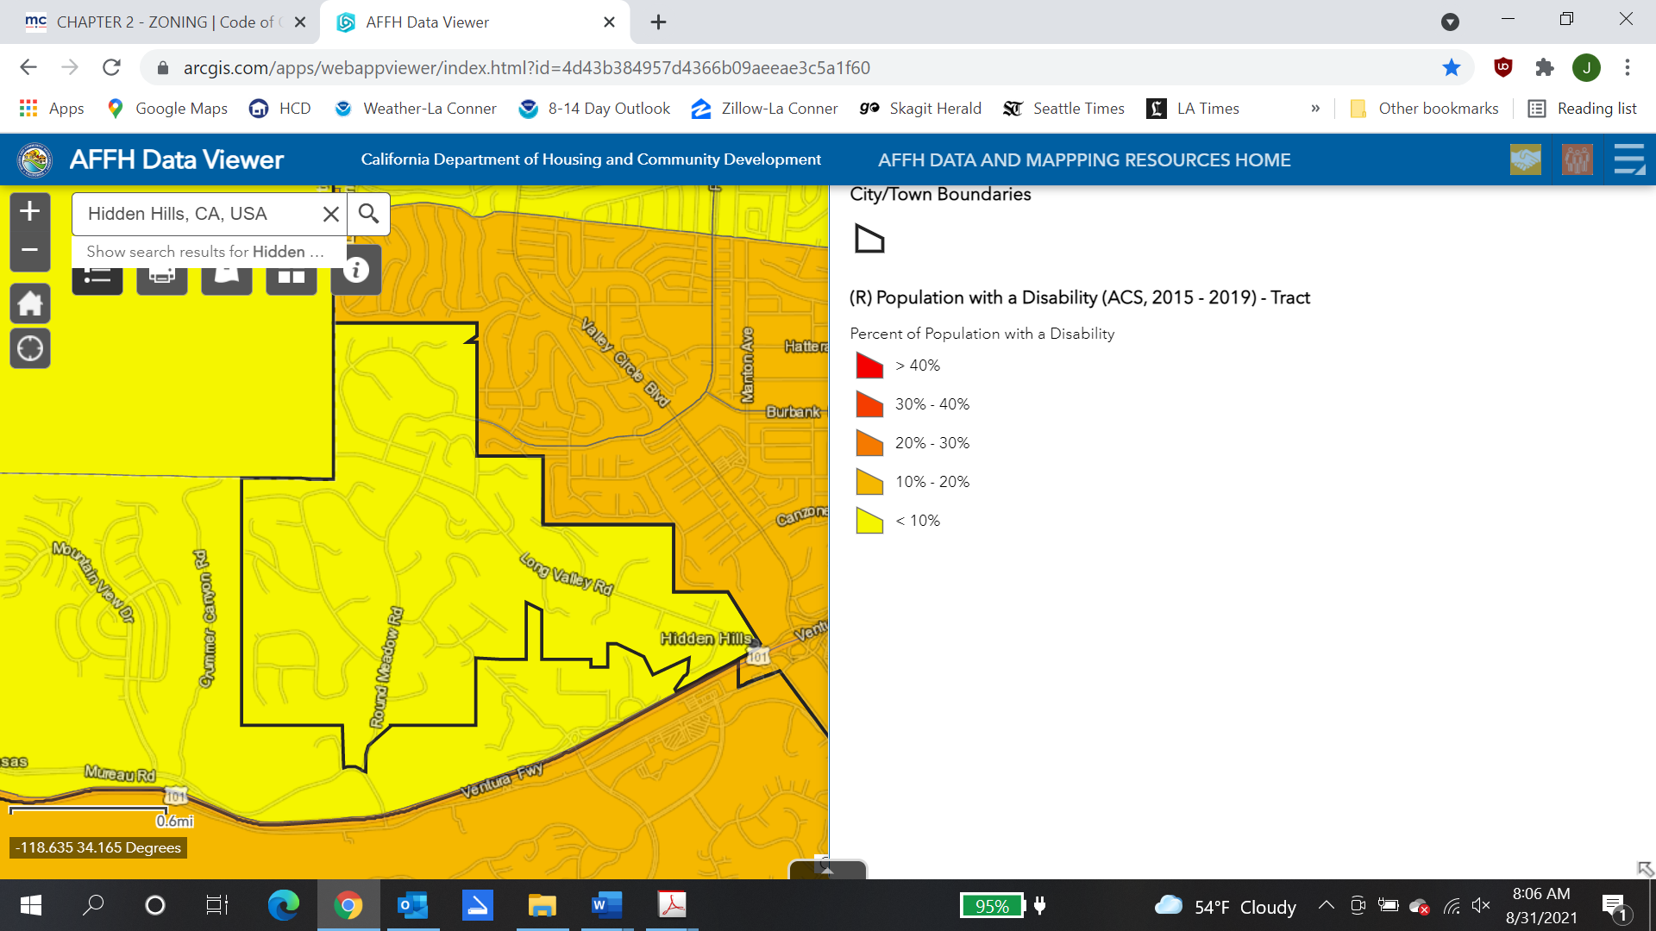
Source: California Department of Housing and Community Development, AFFH Data Viewer, 2021

TCAC/HCD Opportunity Map
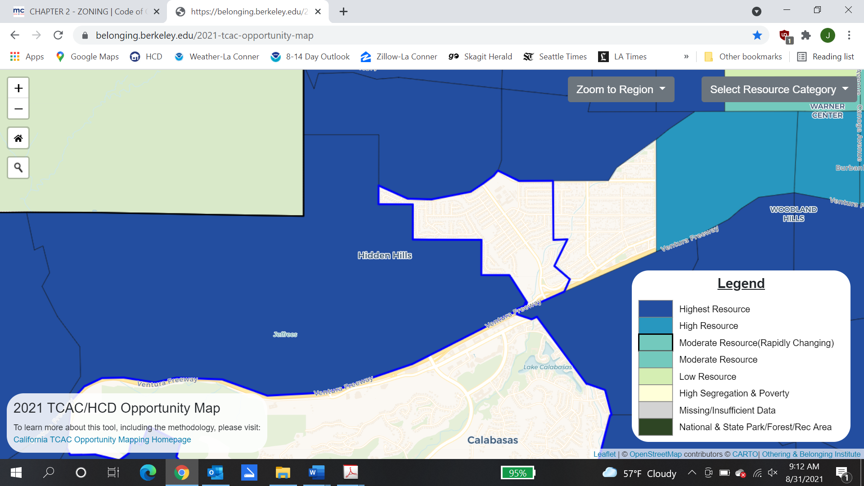

Resources and Opportunities

Land Resources
Section 65583(a)(3) of the Government Code requires Housing Elements to contain an “inventory of land suitable for residential development, including vacant sites and sites having potential for redevelopment, and an analysis of the relationship of zoning and public facilities and services to these sites.” A detailed analysis of vacant land and potential redevelopment opportunities has been prepared (see Appendix B, Table B-2) and the results of this analysis are summarized in Table III-1 below. This analysis demonstrates that the City’s capacity for new housing can accommodate the RHNA in all income categories.

Land Inventory Summary
 | Income Category
 | Lower | Mod | Above
Vacant lots (Table B-2) | - | - | 17
Affordable Housing Overlay (Table B-3) | 29 | - | -
ADUs | 10 | 1 | 5
Total sites | 39 | 1 | 22
RHNA | 25 | 9 | 6
Adequate Capacity? | Yes | Yes* | Yes
Source: City of Hidden Hills, 2021
*Reflects the surplus of lower-income sites

Affordability Assumptions – In 2004 State Housing Element law was amended to clarify the requirements for the land inventory analysis, and established a “default density” for each jurisdiction. The default density is the density that is assumed to be sufficient to facilitate the production of lower-income housing. If a jurisdiction allows development at the default density, then no further analysis is necessary to demonstrate that those sites are suitable for lower-income housing development. The default density for Hidden Hills is 20 units/acre. During the 4th planning cycle the City adopted the Affordable Housing Overlay (AHO), which provides opportunities for lower-income affordable housing in the Commercial-Restricted zone at a density of 20 units/acre, excluding density bonus. In addition to the AHO, accessory dwelling units (ADUs) can provide affordable housing.
Infrastructure Capacity – No major problems currently exist due to inadequate water and sewer capacity. However, all infrastructure was planned by the Las Virgenes Municipal Water District to serve only the levels of development contemplated under the existing deed restrictions, and intensification of development beyond that provided under current planning and zoning policies in this area could be a problem.
Until recently, adequate water pressure could not be provided in some areas of the City due to lack of sufficient water infrastructure in those areas. Some upgrades have been installed, improving flows in deficient areas. However, water systems generally consist of four inch and, in some cases, two inch mains which are not looped, creating a challenge in maintaining adequate fire flows. Thus, new homes are equipped with fire sprinkler systems, where necessary.

Financial and Administrative Resources
Due to the rural, single-family nature of Hidden Hills, the City does not participate in any State or federal housing assistance programs and has no local resources for housing assistance.

Energy Conservation Opportunities
California Government Code §65583(a)(7) requires an analysis of opportunities for energy conservation with respect to residential development. As in most of Southern California, weather in Hidden Hills is generally mild and sunny, a characteristic which is conducive to use of solar power. Income tax credits are offered for use of solar energy and other energy conservation devices. Due to the generally affluent demographic of Hidden Hills, it might be anticipated that a significant number of households could benefit from this tax credit. In addition, the Southern California Gas Company, which serves the area, maintains home weatherization programs to conserve energy, including insulation and use of double paned or other high energy rated windows. Also, passive measures such as home orientation and use of vegetation for shade and shelter may also save energy. The City of Hidden Hills has made information on energy conservation measures available at City Hall.
State law requires all new construction to comply with “energy budget” standards that establish maximum allowable energy use from depletable sources (Title 24 of the California Administrative Code). These requirements apply to such design components as structural insulation, air infiltration and leakage control, setback features on thermostats, water heating system insulation (tanks and pipes) and swimming pool covers if a pool is equipped with a fossil fuel or electric heater. State law also requires that a tentative tract map provide for future passive or natural heating or cooling opportunities in the subdivision, including designing the lot sizes and configurations to permit orienting structures to take advantage of a southern exposure, shade or prevailing breezes.
Southern California Edison (SCE) and the Southern California Gas Company offer energy conservation programs to residents including audits of home energy use to reduce electricity consumption, refrigerator rebates, solar energy equipment rebates, appliance repair and weatherization assistance to qualified low-income households, buyer’s guides for appliances and incentives, by the Gas Company, to switch from electric to gas appliances. Direct assistance to low-income households is provided by the Gas Company through the California Alternate Rates for Energy (CARE) Program and by SCE through its Energy Management Assistance Program.
Both companies have programs to encourage energy conservation in new construction. SCE’s energy rebate program applies to residential developers as well as individual customers. SCE also offers an Energy STAR new home program, and Sustainable Communities Program offering design assistance and financial incentives for sustainable housing development projects. The Gas Company’s Energy Advanced Home Program is offered to residential developers who install energy-efficient gas appliances that exceed California energy standards by at least 15%.

Constraints

Governmental Constraints

Land Use Plans and Regulations

General Plan
Each city and county in California must prepare a comprehensive, long-term General Plan to guide its future. The Land Use Element of the Hidden Hills General Plan establishes the basic land uses and density of development within the various areas of the city. Under State law, the General Plan elements must be internally consistent and the City’s zoning must be consistent with the General Plan. Thus, the land use plan must provide suitable locations and densities to implement the policies of the Housing Element.
The Hidden Hills General Plan Land Use Element provides three residential land use designations, as shown in Table IV-1.

Residential Land Use Categories –
Hidden Hills General Plan
Designation | Maximum  Density¹ | Description | Acreage²
Residential Agricultural, Suburban (RA-1) | 1 du/ac | Single-family detached homes on minimum 1-acre lots; second unit permitted without kitchen facilities. | 821.46
Residential Agricultural, Suburban (RA-2) | 1 du/ac | Single-family detached homes on minimum 1-acre lots; second unit permitted with kitchen facilities. | 88.45
Single Family Residential (R-SF) | 2.2 du/ac | Single-family detached homes on minimum 20,000 SF lots | 1.97
Total
Source: City of Hidden Hills General Plan
1 Density expressed in dwelling units per gross acre
2 Total acreage including developed and vacant land

It should be noted that the minimum lot sizes required by the General Plan are reflective of, and in some areas, less restrictive than, lot sizes required under the Hidden Hills Protective Restrictions included in the Hidden Hills Community Association Covenants, Conditions and Restrictions (CC&Rs) which preceded the establishment of the City of Hidden Hills. Additional information on the CC&Rs can be found in Section IV.B. Non-Governmental Constraints.
The City of Hidden Hills General Plan is not considered a constraint to the goals and policies of the Housing Element as the City’s zoning is consistent with the General Plan and sufficient capacity for new housing has been identified to accommodate the 2021-2029 RHNA.

Zoning Designations and Development Standards
The City regulates the type, location, density, and scale of residential development through the Municipal Code. Zoning regulations serve to implement the General Plan and are designed to protect and promote the health, safety, and general welfare of residents. The Municipal Code also helps to preserve the character and integrity of existing neighborhoods. For example, the City adopted an ordinance amending the standards regarding development on ridgelines. The Municipal Code sets forth residential development standards for each zone district.
The zones that allow residential subdivisions, single-family houses, or accessory dwelling units as a permitted use are as follows:
R-A-S Residential Agricultural Suburban
(one acre minimum lot area)
R-A-S-2 Residential Agricultural Suburban-2
(one acre minimum lot area)
R-1 Residential
(20,000 square feet minimum lot area)
A summary of the development standards for the three zones permitting residential development is provided in Table IV-2. For single-family homes, the smallest allowable lot size is 20,000 square feet (in the R-1 zone); however, there are only five parcels in the R-1 district and most parcels in the city are a minimum of one acre in size. While lots are large by current urban standards in Southern California, it should be recognized that Hidden Hills was planned as a rural single-family residential community in the 1950s with CC&Rs to protect its equestrian character. Further, the city was mostly developed more than 30 years ago when land costs were much lower and the pressures for higher density did not exist. As a result, the potential for new residential development is extremely limited. The City’s development standards continue to be viewed as necessary to protect the public health, safety and welfare and maintain the quality of life as envisioned by the CC&Rs, and are not considered to be unreasonable constraints on the development of housing.

Residential Zones
Development  Standard | Zoning Designations
Development  Standard | R-A-S | R-A-S-2 | R-1
Maximum Density (DU)¹ | 1 du/ac | 1 du/ac | 2.2 du/ac.
Maximum Bldg. Coverage (% of lot) | 30% | 30% | 30%
Minimum Front Yard (ft.) | 50 | 50 | 35
Minimum Side Yard (ft.) | 25 | 25 | 5²
Minimum Rear Yard (ft.) | 50 | 50 | 15³
Maximum Building Envelope Height (ft.) | 26-34⁴ | 26-34⁴ | 26-34⁴
Source: Hidden Hills Zoning Code
Notes:
1. Density expressed in dwelling units per net acre.
2. Minimum yard setback is 25 feet if adjacent to R-A-S zone.
3. Rear yard may be reduced to 5 feet when abutting the C-R zone.
4. Depending on setback.

- The R-A-S Zone differs from the R-A-S-2 Zone primarily in that the R-A-S-2 Zone allows additional building height and larger accessory units. Building height is regulated through the building height envelope and building height cap.
The building height envelope is defined as: The vertical dimension of the building as measured from each point in the pre-existing grade to the directly vertical point of the finished roof (excluding chimneys).
The building height cap is defined as: The greatest vertical dimension of a building as measured from the lowest point where the foundation adjoins the finished exterior grade to the top of the highest portion of the finished rood (excluding chimneys).
All height, lot coverage, and setback requirements are consistent with Hidden Hills Community Association requirements. The overall intent of the City’s residential zoning standards is to preserve the community’s rural equestrian character and privacy through large lots, low maximum coverage requirements and ample setbacks. Relaxation of the standards by the City would have little or no effect on development due to the separate Association requirements that apply to all parcels in the city, but for a few.

Permitted Residential Development by Zone
Housing Type Permitted | R-A-S | R-A-S 2 | R-1
Single-Family Detached | P | P | P
Single-Family Attached
Multi-Family
Transitional & Supportive Housing | P | P | P
Res. Care Facilities (6 or fewer clients) | C | C | C
Manufactured Housing* | P | P | P
Mobile Home* | P | P | P
Accessory Dwelling Units | P | P | P
Source: Hidden Hills Zoning Code
P – permitted use C – conditional use
*On a permanent foundation

In addition to the permitted residential uses shown in Table IV-3, lower-income multi-family housing is permitted by-right in the Commercial Restricted (CR) zone subject to the Affordable Housing Overlay (AHO) regulations.

Special Needs Housing
Housing for persons with special needs includes residential care facilities, employee housing, emergency shelters, transitional housing, supportive housing, and single-room-occupancy units. Many of these types of housing serve the needs of extremely-low-income households. The City’s provisions for these housing types are discussed below.
Extremely Low-Income Households
Many persons and households served by special needs housing fall within the extremely-low-income category, which is defined as 30% or less of area median income.
Residential Care Facilities
Residential care facilities refer to any family home, group home, or rehabilitation facility that provides non-medical care to persons in need of personal services, protection, supervision, assistance, guidance, or training essential for daily living. Licensed residential care facilities that serve six or fewer persons are allowed as a single-family residential use in all residential zones. Facilities serving more than six persons are not currently permitted within the city. These regulations are consistent with State law.
Housing for Persons with Disabilities
Both the federal Fair Housing Act and the California Fair Employment and Housing Act impose an affirmative duty on local governments to make reasonable accommodations (i.e. modifications or exceptions) in their zoning laws and other land use regulations when such accommodations may be necessary to afford disabled persons an equal opportunity to use and enjoy a dwelling. The Building Codes adopted by the City of Hidden Hills incorporate accessibility standards contained in Title 24 of the California Administrative Code.
In addition, cities can adopt “reasonable accommodation” procedures to streamline the approval process for adjustments to regulations and standards where necessary to improve accessibility for persons with disabilities. In 2012 the City Council adopted a reasonable accommodation ordinance in conformance with State law. The ordinance allows the Planning Director to approve reasonable accommodation requests administratively (i.e., without a public hearing). There is no fee for filing a reasonable accommodation request, and if the request is associated with a discretionary permit the applications are processed concurrently. This simplified reasonable accommodation process helps to address the needs of persons with all types of disabilities, including developmental disabilities.
Farm Worker Housing
As discussed in Chapter II, (Needs Assessment), Hidden Hills is not located within or near a major agricultural area and has no significant need for farm worker housing. However, in conformance with the State Employee Housing Act, the Municipal Code allows agricultural employee housing for up to six persons as a single-family residential use. In addition, employee housing consisting of no more than 36 beds in a group quarters or 12 units or spaces designed for use by a single household must be deemed an agricultural land use (Health and Safety Code Sec. 17021.6). Program 7d in the Housing Plan (Chapter V) includes a commitment to process an amendment to the Zoning Ordinance to incorporate current requirements regarding agricultural employee housing consistent with State law.
Emergency Shelters and Low Barrier Navigation Centers
The Municipal Code defines Emergency Shelter as “Housing with minimal supportive services for homeless persons that limits occupancy by homeless persons to six months or less and that does not deny emergency shelter due to a person's inability to pay.”
As discussed in Chapter II, no homeless persons have been observed in Hidden Hills, and there is no demand for a shelter in the city. However, in conformance with State law the Municipal Code allows emergency shelters by-right in the Commercial-Restricted (C-R) zone subject to appropriate development standards. The C-R zone encompasses 1.5 acres and can accommodate at least one emergency shelter. Standards for emergency shelters include the following:
- Submittal of a Management and Operations plan;
- Maximum of 6 beds;
- Minimum distance of 300 feet between emergency shelters;
- Maximum length of stay of 180 days in any 365-day period;
- Minimum of one employee, in addition to security personnel, on duty during operational hours;
- Security personnel shall be provided during operational hours;
- Exterior lighting;
- Minimum parking of one space per 4 beds plus one for each employee or volunteer on duty, plus a bicycle rack.
Recent changes to State law modified the allowable parking standards for emergency shelters; therefore, the Housing Plan includes Program 7b to process a Code amendment to update parking standards consistent with current State law.
In 2019 the State Legislature adopted AB 101 establishing requirements related to local regulation of low barrier navigation centers, which are defined as “Housing first, low-barrier, service-enriched shelters focused on moving people into permanent housing that provides temporary living facilities while case managers connect individuals experiencing homelessness to income, public benefits, health services, shelter, and housing.” Low barrier means best practices to reduce barriers to entry, and may include, but is not limited to:
(1) The presence of partners if it is not a population-specific site, such as for survivors of domestic violence or sexual assault, women, or youth
(2) Accommodation of residents’ pets
(3) The storage of possessions
(4) Privacy, such as partitions around beds in a dormitory setting or in larger rooms containing more than two beds, or private rooms
Low barrier navigation centers meeting specified standards must be allowed by-right in areas zoned for mixed use and in nonresidential zones permitting multi-family uses. Program 7b in the Housing Plan includes a commitment to process an amendment to the Zoning Code in compliance with this requirement.
Transitional and Supportive Housing
“Transitional housing” means buildings configured as rental housing developments, but operated under program requirements that require the termination of assistance and recirculating of the assisted unit to another eligible program recipient at a predetermined future point in time that shall be no less than six months from the beginning of the assistance (Government Code Sec 65582[j]).
“Supportive housing” means housing with no limit on length of stay, that is occupied by the target population, and that is linked to an onsite or offsite service that assists the supportive housing resident in retaining the housing, improving his or her health status, and maximizing his or her ability to live and, when possible, work in the community (Government Code Sec 65582[g]). “Target population” means persons with low incomes who have one or more disabilities, including mental illness, HIV or AIDS, substance abuse, or other chronic health condition, or individuals eligible for services provided pursuant to the Lanterman Developmental Disabilities Services Act (Division 4.5 (commencing with Section 4500) of the Welfare and Institutions Code) and may include, among other populations, adults, emancipated minors, families with children, elderly persons, young adults aging out of the foster care system, individuals exiting from institutional settings, veterans, and homeless people (Government Code Sec 65582[i]).
The City Zoning Ordinance allows transitional or supportive housing facilities subject to the same standards and procedures as apply to other residential uses of the same type in the same zone. In 2018 AB 2162 amended State law to require that supportive housing be a use by-right in zones where multi-family and mixed uses are permitted, including non-residential zones permitting multi-family uses, if the proposed housing development meets specified criteria. Program 7c in the Housing Policy Plan includes a commitment to process an amendment to the Zoning Ordinance in compliance with current State law.
Single Room Occupancy
Single room occupancy (SRO) facilities are small studio-type multi-family units, typically intended for lower-income residents or senior citizens. Multi-family housing developments (including SROs) are permitted in the CR zone pursuant to the Affordable Housing Overlay regulations (Municipal Code Sec. 5-2F-9).

Off-Street Parking Requirements
The Zoning Code requires a minimum of two parking spaces in a fully enclosed garage for every single-family home, regardless of the number of bedrooms. Parking requirements for multi-family or mixed-use developments in the Affordable Housing Overlay would be established through density bonus regulations (Municipal Code Sec. 5-2M-1 et seq.).

Accessory Dwelling Units
Given that domestic service is a significant source of employment within Hidden Hills, ADUs can provide affordable housing for low-income residents working in the community. Accessory units also serve to augment resources for senior housing, or other segments of the population. The Housing Plan (Chapter V) contains Program 5b to continue to encourage the development of additional ADUs as a key component of the City’s strategy for meeting its share of regional housing needs for lower-income persons.

Density Bonus
State density bonus law provides incentives to developers to include low- and moderate-income housing units in their developments. AB 2345 of 2019 amended State law to revise density bonus incentives that are available for affordable housing developments. Program 5c in the Housing Plan includes a commitment to review City density bonus regulations and process an amendment to reflect these changes to State law.

Mobile Homes/Manufactured Housing
There is often an economy of scale in manufacturing homes in a plant rather than on site, thereby reducing cost. State law precludes local governments from prohibiting the installation of mobile homes on permanent foundations on single-family lots. It also declares a mobile home park to be a permitted land use on any land planned and zoned for residential use, and prohibits requiring the average density in a new mobile home park to be less than that permitted by the Municipal Code. The City’s Zoning Code allows mobile homes or manufactured housing on a permanent foundation in all residential zones in conformance with State law.

Inclusionary Zoning
The City has not adopted any inclusionary zoning requirements.

Short-Term Rentals
The City has not adopted any short-term rental restrictions.

Building Codes
State law prohibits the imposition of building standards that are not necessitated by local geographic, climatic or topographic conditions. Further, State law requires that local governments making changes or modifications in building standards must report such charges to the Department of Housing and Community Development and file an expressed finding that the change is needed.
The City's building codes are based upon the California Building, Plumbing, Mechanical, Fire and Electrical Codes. These are considered to be the minimum necessary to protect the public's health, safety and welfare.
In only minor cases do City standards differ from State building codes. City amendments have been adopted in the areas of soil and erosion, pool barriers, fire, architectural, and structural requirements. While some of these may add to building costs, they are deemed reasonable and necessary to protect public health and safety.

Development Processing Procedures

Residential Permit Processing
State Planning and Zoning Law provides permit processing requirements for residential development. Within the framework of State requirements, the City has structured its development review process in order to minimize the time required to obtain permits while ensuring that projects meet applicable requirements. It should be noted that nearly all projects require approval of the Hidden Hills Association’s Architectural Committee, which adds to project review time. However, projects that obtain Association approval are exempt from City site plan review. If required, the City’s site plan review process focuses on the physical design of buildings to ensure that they are compatible with adjacent properties in terms of building height, scale, and privacy (e.g., building separation and placement of windows, decks and balconies), and that topographic features are preserved to the extent feasible. Site plan review applications are reviewed by the City Council at a public hearing.
Plan check for processing of building permits is generally one to two weeks, which is less time than in most communities.
For discretionary permits such as conditional use permits or variances for projects not meeting basic standards, processing typically takes 90 days from the time an application is determined to be complete, including mandated public review and noticing periods.

Environmental Review
Environmental review is required for all development projects under the California Environmental Quality Act (CEQA). Most residential projects in Hidden Hills are either Categorically Exempt or require an Initial Study and a Mitigated Negative Declaration. Developments that have the potential of creating significant impacts that cannot be mitigated require the preparation of an Environmental Impact Report. Once deemed complete, most residential projects that require a Mitigated Negative Declaration take two to three months to complete, inclusive of mandatory public review periods. Categorically Exempt developments such as ADUs require a minimal amount of time. As a result, while State-mandated environmental review may add to permit review times, the City has no authority to reduce or eliminate these requirements.

Development Fees and Improvement Requirements
State law limits fees charged for development permit processing to the reasonable cost of providing the service for which the fee is charged. Various fees and assessments are charged by the City and other public agencies to cover the costs of processing permit applications and providing services and facilities such as schools, parks and infrastructure. These fees are assessed through a pro rata share system, based on the magnitude of the project's impact or on the extent of the benefit that will be derived.
Table IV-4 shows the development fees the City charges for new single-family residential development. Development fees are estimated at approximately $20,000 to $80,000 per unit which is modest in comparison to property values. Unlike many urban and suburban jurisdictions, Hidden Hills has no traffic impact fee.
The City periodically evaluates the actual cost of processing the development permits when revising its fee schedule.

Development Fee Summary
Fee Category | Fee or Deposit Amount
Planning and Application Fees
Conditional Use Permit | $8,078
Minor Accommodation (w/out CC review) | $968
Variance | $3,709
Tentative Tract Map | $15,189 + $549/lot
Site Plan Review | $759
Minor Site Plan Review | $210
Lot Line Adjustment | $2,580
Environmental
Environmental Review/Initial Study | $1,935+ Actual cost of document preparation
Public Works
Curb and Gutter | Actual cost
Sidewalks | Actual cost
Curb Drains | Actual cost
Residential Driveways | Actual cost
City Engineering
Grading Plan Check & Permit | Dependent on quantities.  50 cu.yd.: $923.46 plan check + $314.16 permit  500,000 cu.yd.: $33,295 plan check + $16,215 permit
Plan Check | $1,519 + 7.20% of first $50,000 of improvement cost + 5.75% of next $100,000 of improvement cost + 4.30% of improvement cost thereafter
Construction Permit | $1,371+$158 Issuance fee + 11.50% of first $1000,000 of improvement cost + 10% of next $100,000 of improvement cost + 8.6% of improvement cost thereafter
Residential Inspection (where no other fee exists) | $178.50/hr.
Las Virgenes Municipal Water District Fees
Water Hookup | $24,685
Sewer Hookup | $11,669
Typical Cost for One Single-Family Unit | $20,000 – 80,000
Source: City of Hidden Hills, 2021

Hidden Hills is located in a hilly area and roadways are typically narrow and winding. The Circulation Element identifies three collector streets (Long Valley Road, Round Meadow Road, and Spring Valley Road) and no arterials. Long Valley Road, the major collector for the City, is 26 feet wide, including 3-foot concrete swales. The remaining roadways are all local streets. All streets are owned and maintained by the Community Association except for small areas outside the security gates. The General Plan requires new private roads to have a minimum right-of-way width of 60 feet and that all streets be designed to keep the rural, equestrian character of the community. Typically, local streets are minimally improved with paving, rolled gutters and equestrian trails. These policies preclude excessive improvement standards that could act as an unreasonable constraint to housing development in Hidden Hills.
After the passage of Proposition 13 and its limitation on local governments’ property tax revenues, cities and counties have faced increasing difficulty in providing public services and facilities to serve their residents. One of the main consequences of Proposition 13 has been the shift in funding of new infrastructure from general tax revenues to development impact fees and improvement requirements on new development. The City requires developers to provide on-site and off-site improvements necessary to serve their projects. Such improvements may include water, sewer and other utility extensions, street construction and traffic control device installation that are reasonably related to the project. Dedication of land or in-lieu fees may also be required of a project for rights-of-way, transit facilities, recreational facilities and school sites, consistent with the Subdivision Map Act.
Although development fees and improvement requirements increase the cost of housing, cities have little choice in establishing such requirements due to the limitations on property taxes and other revenue sources needed to fund public improvements. Compared to most other jurisdictions in the region, development fees in Hidden Hills are low in relation to property values.

Non-Governmental Constraints

Private Codes, Covenants, and Restrictions (CC&Rs)
Most residential land in the City is subject to the Hidden Hills Community Association CC&Rs, which were adopted at the time of the original subdivisions forming the bulk of the city. Eighteen separate sets of deed restrictions have been recorded since 1950. The CC&Rs are comprehensive and apply to everything from land use to architectural review.
The Hidden Hills Community Association, a private homeowner’s association, currently oversees compliance with the CC&Rs. The Association has an independently elected board, outside the control of the City of Hidden Hills. The City has no authority to modify or remove the restrictions. Amendment of the CC&Rs requires an affirmative vote of two-thirds of the membership of the Association as well as approval of their lenders.
The CC&Rs are reflected in the City’s General Plan and Zoning Code, which establish the basic land uses, densities, and development requirements for the city. However, new housing within the Association is subject to the Association’s Architectural Standards and requires approval of the Association’s Architectural Commission. Any subdivision of property also requires the Association’s approval. The timeframe for Architectural Review can vary considerably and is not under City control.
Additionally, all City residents must pay an annual assessment for maintenance, improvements and other Association expenses. These assessments are in addition to property taxes, adding to the cost of home ownership in the city.

Environmental Constraints
Environmental constraints include physical features such as steep slopes, fault zones, floodplains, sensitive biological habitat, agricultural lands, and areas located within very high fire hazard zones. In many cases, development of these areas is constrained by State and federal laws (e.g., FEMA floodplain regulations, the Clean Water Act and the Endangered Species Act, the State Fish and Game Code, and the Alquist-Priolo Act).
The City of Hidden Hills is characterized by rolling to rugged terrain, which presents significant constraints to the development of the remaining vacant land.
Hidden Hills is located in County Fire Zone 3, a high brush fire hazard area, and the southern portion of the city is within the Very High Fire Hazard Severity Zone as designated by Cal Fire. The City’s building code requires fire retardant roofs for all residential structures.
Significant geologic constraints are also imposed by active landslides and potentially active landslides within the city. Geologic risks are addressed by Public Safety Element policies, and through the building permit review process.
The City’s land use plans have been designed to protect sensitive areas from development, and protect public safety by avoiding development in hazardous areas. While these policies constrain residential development to some extent, they are necessary to support other public policies and ensure public safety.

Infrastructure Constraints
Wastewater Treatment. The Las Virgenes Municipal Water District (LVMWD) provides sanitary sewer service for the city through local collector sewers operated by the Los Angeles County Consolidated Sewer Maintenance District. Sewage collected in the city is discharged for treatment in the City of Los Angeles’ wastewater facilities at their Tillman and Hyperion Treatment plants, in accordance with an agreement between the LVMWD and the City of Los Angeles. City staff has confirmed that the wastewater treatment system has the capacity to serve all present and projected future water needs, and therefore is not a constraint to housing production consistent with the RHNA allocation for the planning period.
Water Supply. Domestic water for City residents is supplied by LVMWD. The LVMWD obtains all of its water supply from the Metropolitan Water District of Southern California (MWD), part of the State Water Project. According to the LVMWD, portions of the City’s water system have not been updated to the 1,250 gallon-per-minute minimum requirements currently required by the Los Angeles County Fire Department. While the County has not indicated a need to upgrade the older lines, new development must meet the 1,250 GPM standard. City staff has confirmed with LVMWD that domestic water supply is not expected to preclude development consistent with the RHNA allocation for the planning period.
Storm Water Drainage. Storm water runoff is handled by a flood control system owned maintained Los Angeles County Department of Public Works. According to Federal Emergency Management Agency maps, the City of Hidden Hills has a low potential for flooding; therefore, storm water drainage is not expected to act as a constraint to housing development.

Land Costs
Land represents one of the most significant components of the cost of new housing and land values fluctuate with market conditions. In Hidden Hills land costs represent a relatively high proportion of total housing costs, due in part to large lot sizes. As the remaining developable land has become scarcer, the price of land in the City has risen. In addition, the land which has not yet been developed tends to have more environmental constraints, such as topographical features that require extensive grading, and is thus more costly to develop. Typical land cost is currently $2 million for a one-acre parcel in the residential zones.

Construction Costs
Construction cost is affected by the price of materials, labor, development standards and general market conditions. The City has no influence over materials and labor costs, and the building codes and development standards in Hidden Hills are not substantially different than other cities with similar topographical conditions in Los Angeles County. Because all new housing development is custom homes on relatively difficult sites, construction cost is typically much higher than for tract-type production housing.

Cost and Availability of Financing
Hidden Hills is similar to most other Southern California communities with regard to private sector home financing programs. One of the most significant changes brought about by the “Great Recession” was a tightening of mortgage underwriting standards, which has impacted low-income families more than other segments of the community. For those with good credit ratings, interest rates have been at historic lows, resulting in increased affordability.

Housing Plan
The primary focus of the Housing Element is to meet existing and anticipated housing needs and to protect existing residential neighborhoods in Hidden Hills. The policies and implementation measures of the Housing Element are aimed at preserving the quality of the living environment, protecting the lower-density character of the area, conserving the existing housing stock, addressing local and regional housing needs, providing for the City's share of housing for all economic groups and persons with disabilities, providing housing assistance to lower-income residents, and ensuring fair housing practices.

Goals, Policies and Implementation Programs
GOAL I. Preserve the quality of existing neighborhoods to provide a safe and healthful living environment for all residents.
Policy 1. Preserve the scale of development in existing residential neighborhoods.
Program 1. Zoning and Development Standards. Continue to enforce the Zoning Code, which regulates height, lot coverage, setbacks, open space, etc.
Funding source: General Fund; plan check/permit fees
Implementation schedule: Continuous
Responsibility: Planning staff
Policy 2. Encourage the maintenance of existing dwellings in order to maintain public health and safety.
Program 2. Property Maintenance. Pursue pro-active code enforcement and work cooperatively with the Hidden Hills Community Association to encourage property maintenance, including sharing information regarding problem properties to the extent permitted consistent with preservation of privacy of the homeowner.
Funding source: General Fund
Implementation schedule: Continuous
Responsibility: Planning and Building staff
GOAL II. Provide housing opportunities for all economic segments of the community, including persons with special needs.
Policy 3. Provide adequate sites for new housing consistent with the capacity of infrastructure to handle increased growth.
Program 3. Infill Residential Development. Encourage development of existing vacant residential infill sites and accessory dwelling units (see also Program 5b).
Funding source: General Fund and permit revenue
Implementation schedule: Continuous
Responsibility: Planning and Building staff
Policy 4. Preserve existing affordable housing stock.
Program 4a. Reverse Mortgages. Encourage the provision of reverse mortgages by local lending institutions and increase community awareness of such alternatives by posting information in City Hall and on the City’s website.
Funding source: General Fund
Implementation schedule: Post information on reverse mortgages throughout the planning period
Responsibility: Planning staff
Program 4b. Reduced Association Fees. Continue to work cooperatively with the Hidden Hills Community Association to waive or reduce Association fees for low- and moderate-income households.
Funding source: General Fund
Implementation schedule: Throughout the planning period.
Responsibility: Planning staff
Policy 5. Facilitate the development of additional extremely-low-, very-low-, low- and moderate-income housing, as well as housing for persons with developmental disabilities.
Program 5a. Development Streamlining. Continue efforts to reduce housing costs by streamlining the development review process to the extent feasible for projects that include extremely-low-income units and supportive housing for persons with developmental disabilities. Provide concurrent processing of all discretionary applications for a project. Improve plan check efficiencies through use of computer permit tracking systems.
Funding source: General Fund and development fee revenues
Implementation schedule: Continuous
Responsibility: Planning, Engineering and Building staff
Program 5b. Accessory Dwelling Units. ADUs are an important component of the City’s strategy to facilitate production of low- and moderate-income housing, including extremely-low-income units and supportive housing for persons with developmental disabilities. In recent years the State Legislature has amended housing law to incentivize production of ADUs. The City will ensure that zoning regulations are consistent with State ADU law as it may be amended from time to time. In addition, the City will offer Incentives to encourage ADU development, including the following:
    - Allow modification of development standards (e.g., setbacks), if necessary to accommodate ADUs
    - Fast-track ADU plan review and permit processing
    - Marketing and promotion of ADUs to applicants for new construction or substantial remodels when applications are received
    - Provide direct mail flyers to all households in the city promoting ADUs
    - Monitor the results of this program and report to the City Council and HCD annually on program accomplishments. If the program’s incentives are found not to be effective in facilitating additional ADU development, revised program actions will be initiated.
Funding source: General Fund
Implementation schedule: Monitor changes to State ADU law and amend City ADU regulations as necessary to ensure conformance with current law by 10/2022;
Provide fast track processing for ADUs throughout the planning period;
Offer modified development standards for ADUs, if necessary, throughout the planning period;
Make ADU information materials available throughout the planning period;
Responsibility: Planning staff
Program 5c. Density Bonus Ordinance. State law requires cities to allow increased density and other incentives when housing developments provide affordable units. The City will continue to monitor changes to State law and process amendments to the City’s Density Bonus Ordinance as necessary to maintain consistent with current State law.
Funding source: General Fund
Implementation schedule: Density Bonus Ordinance amendment by 10/2022; Implementation throughout the planning period
Responsibility: Planning staff
Program 5d. Affordable Housing Overlay. Continue to implement the Affordable Housing Overlay (AHO) zoning regulations and facilitate development of qualifying affordable owner-occupied or multi-family rental developments in the Commercial-Restricted (CR) zone. The AHO regulations include the following provisions:
- Qualifying projects shall have a minimum density of 20 units/acre, excluding density bonus.
- Qualifying projects shall restrict all units in the development, except for a manager’s unit, for occupancy by lower-income households for a period of not less than 30 years.
- Qualifying projects shall have a minimum of 16 units per site
- Qualifying projects shall be permitted by-right (i.e., limited to non-discretionary design review).
- Development other than a qualifying affordable housing project within the AHO shall require approval of a conditional use permit, with the exception of the continuation, modification or change of an existing use in an existing structure provided the modification or change of use does not require a discretionary planning permit. Approval of a CUP shall require a finding that the development will not reduce the capacity of available land in the AHO below the amount necessary to accommodate the remaining lower-income RHNA for the planning period.
- To address the housing needs of extremely-low-income households and persons with special needs, including developmental disabilities, the City will:
      - Biennially contact developers, including non-profit, to assist with seeking or supporting State and Federal monies, as funding becomes available for support of housing construction and/or rehabilitation;
      - Provide regulatory incentives, such as expedited permit processing and fee waivers and deferrals (see Programs 4.b and 5.a); and
      - The City shall work with the North Los Angeles County Regional Center to implement an outreach program informing families in Hidden Hills of housing and services available for persons with developmental disabilities. Information will be made available on the City’s website.
Funding source: General Fund
Implementation schedule: Throughout the planning period
Responsibility: Planning staff
Policy 6. Promote housing opportunities for all persons regardless of race, religion, sex, marital status, ancestry, national origin, color, familial status or disability.
Program 6. Affirmatively Further Fair Housing. The City will continue to promote fair housing policies through the following actions:
    - Post State regulations regarding housing discrimination together with the appropriate phone numbers to contact regarding housing discrimination problems at City Hall.
    - Provide a referral process for any persons who believe they have been denied access to housing because of their race, religion, sex, marital status, ancestry, national origin, color, familial status or disability. The City will refer complainants to appropriate agencies, legal service organizations, and/or non-profit housing groups that specifically handle housing discrimination issues such as the Fair Housing Congress of Southern California and the Fair Housing Council of San Fernando Valley. The City will publicize fair housing information on the City’s website and in the City’s newsletter.
Funding source: General Fund
Implementation schedule: Publicize fair housing information throughout the planning period
Responsibility: Planning staff
Policy 7. Accommodate the housing needs of special population groups.
Program 7a. Accessible Housing. The City will continue to implement the current Zoning Code and the State provisions (Title 24) for handicapped access, and allow residential care facilities consistent with State law. Through the continued implementation of the Reasonable Accommodation Ordinance, the City will facilitate the streamlined approval of modifications to zoning and building regulations needed to accommodate the needs of persons with disabilities, including developmental disabilities.
Funding source: General Fund
Implementation schedule: Throughout the planning period
Responsibility: Planning staff
Program 7b. Emergency Shelters and Low Barrier Navigation Centers. Emergency shelters shall be permitted by-right in the C-R zone subject to appropriate development standards consistent with State law. The C-R zone contains approximately 1.5 acres, has the capacity for at least one shelter, and is within walking distance of public transit. In conformance with recent changes to State law, the City will process a Zoning Ordinance amendment to revise parking standards for emergency shelters consistent with Government Code Sec. 65583(a)(4)(A).
AB 101 (2019) added the requirement that low barrier navigation centers meeting specified standards be allowed by-right in areas zoned for mixed use and in non-residential zones permitting multi-family uses pursuant to Government Code §65660 et seq. An amendment to the Zoning Ordinance will be processed to incorporate current requirements regarding low barrier navigation centers consistent with State law.
Funding source: General Fund
Implementation schedule: Zoning Ordinance amendment by 10/2022
Responsibility: Planning staff
Program 7c. Transitional and Supportive Housing. State law requires that transitional and supportive housing be considered a residential use subject to the same requirements and procedures that apply to other residential uses of the same type in the same district. In 2018 AB 2162 amended State law to also require that supportive housing be permitted by-right in zones where multi-family and mixed uses are permitted, including non-residential zones permitting multi-family uses, if the proposed housing development meets specified criteria. An amendment to the Zoning Ordinance will be processed to incorporate current requirements regarding supportive housing consistent with State law.
Funding source: General Fund
Implementation schedule: Zoning Ordinance amendment by 10/2022
Responsibility: Planning staff
Program 7d. Agricultural Employee Housing. The City will continue to permit employee housing for up to six persons as a single-family residential use in residential zoning districts in conformance with Health and Safety Code Sec. 17021.5. In addition, employee housing consisting of no more than 36 beds in a group quarters or 12 units or spaces designed for use by a single family or household shall be deemed an agricultural land use (Health and Safety Code Sec. 17021.6). An amendment to the Zoning Ordinance will be processed to incorporate current requirements regarding agricultural employee housing consistent with State law.
Funding source: General Fund
Implementation schedule: Zoning Ordinance amendment by 10/2022
Responsibility: Planning staff
GOAL III. Encourage the conservation of energy in housing.
Policy 8. Reduce energy loss due to inferior construction techniques.
Program 8. Residential Energy Conservation. Continue to require all new residential projects to conform to the requirements of Title 24 of the California Administrative Code. Title 24 contains specific requirements for energy conservation which result in energy savings of approximately 50 percent when compared to standard construction techniques utilized prior to enactment of current standards. In addition, local utility companies regularly circulate information regarding energy conservation to their residential customers. To support such programs, the City will allow posting of energy conservation materials on public bulletin boards in order to publicize conservation efforts.
Funding source: General Fund
Implementation schedule: Ongoing throughout the planning period
Responsibility: Planning staff

Quantified Objectives
The City’s quantified objectives for new construction, rehabilitation and conservation are presented in Table V-1. Since the City has no source of housing funds, no rehabilitation or conservation objectives are established.

Quantified Objectives (2021-2029)
 | Income Category
 | Ex. Low | V. Low | Low | Mod | Above Mod | Totals
New construction | 9 | 8 | 8 | 9 | 6 | 40
Rehabilitation | 0 | 0 | 0 | 0 | 0 | 0
Conservation | 0 | 0 | 0 | 0 | 0 | 0

This page intentionally left blank.

- Evaluation of the Prior Housing Element
Section 65588(a) of the Government Code requires that jurisdictions evaluate the effectiveness of the existing Housing Element, the appropriateness of goals, objectives and policies, and the progress in implementing programs for the previous planning period. This appendix contains a review of the housing goals, policies, and programs of the previous Housing Element, and evaluates the degree to which these programs have been implemented during the previous planning period, 2013 through 2021. This analysis also concluded that the goals and policies of the prior element continue to be appropriate. The findings from this evaluation have been instrumental in determining the City’s 2021-2029 Housing Plan.
Table A-1 summarizes the programs contained in the previous Housing Element along with the source of funding, program objectives, accomplishments, and implications for future policies and actions.
Table A-2 summarizes residential development in the city during 2013-2021.
Table A-3 presents the City’s progress in meeting the quantified objectives from the previous Housing Element.

Table A-1
Housing Element Program Evaluation (2013-2021)
City of Hidden Hills
Program | Objective | Schedule | Status
Program 1. Zoning and Development Standards. Continue to enforce the Zoning Code, which regulates height, lot coverage, setbacks, open space, etc. | Ensure compliance with zoning and development standards | Ongoing | The City continued to implement this program.
Program 2. Property Maintenance. Pursue pro-active code enforcement and work cooperatively with the Hidden Hills Community Association to encourage property maintenance, including sharing information regarding problem properties to the extent permitted consistent with preservation of privacy of the homeowner. | Encourage property maintenance | Ongoing | The City continued code enforcement activities
Program 3. Infill Residential Development. Encourage development of existing vacant residential infill sites and second units (see also Program 5b). | Additional development of homes and second units consistent with housing needs | Ongoing | The City encouraged infill development by making information regarding second units available to homeowners.
Program 4a: Reverse Mortgages. Encourage the provision of reverse mortgages by local lending institutions and increase community awareness of such alternatives by posting information in City Hall and on the City’s website. | Provide information on reverse mortgages | Ongoing | Reverse mortgage information continues to be posted in City Hall and on the City website.
Program 4b. Reduced Association Fees. Work with the Hidden Hills Community Association to waive or reduce Association fees for low- and moderate-income households. | Waived or reduced Association fees for low- and moderate-income households | Ongoing | City staff contacted the Community Association and requested that fees be reduced or waived for low- and moderate-income households.
Program 5b. Second Units. Provide incentives for development of additional second units as a component of the City’s strategy to facilitate production of low- and moderate-income housing, including extremely-low-income units and supportive housing for persons with developmental disabilities. These incentives will include the following:  - Modification of development standards (e.g., setbacks), if necessary to accommodate second units Fast-track plan review and permit processing for second units Marketing and promotion of second units to applicants for new construction or substantial remodels when applications are received  - Provide direct mail flyers to all households in the city promoting second units  - Pursue discussions with the Hidden Hills Community Association regarding the potential for relaxation of private second unit deed restrictions  - Monitor the results of this program and report to the City Council and HCD annually on program accomplishments. If the program’s incentives are found not to be effective in facilitating additional second unit development, revised program actions will be initiated. | Facilitate production of additional second units | Provide fast track processing for second units throughout the planning period;Offer modified development standards for second units, if necessary, throughout the planning period; Make second unit information materials available throughout the planning period;Biannual discussions with the Community Association. | Fast-track permit processing for second units was continued.Modified development standards were made available for second units deed-restricted for lower-income households.A flyer promoting second units and incentives was posted at City Hall and on the City website.
Program 5c. Density Bonus Ordinance. The City will continue to implement the Density Bonus Ordinance consistent with current state law. | Continue to encourage production of affordable units through implementation of the Density Bonus Ordinance | Ongoing | The City continued to implement the Density Bonus ordinance; however, no requests for density bonus were submitted.
Program 5d. Affordable Housing Overlay. Continue to implement the Affordable Housing Overlay (AHO) zoning regulations and facilitate development of qualifying affordable owner-occupied or multi-family rental developments in the Commercial-Restricted (CR) zone. The AHO regulations include the following provisions:Qualifying projects shall have a minimum density of 20 units/acre, excluding density bonus.Qualifying projects shall restrict all units in the development, except for a manager’s unit, for occupancy by lower-income households for a period of not less than 30 years.Qualifying projects shall have a minimum of 16 units per siteQualifying projects shall be permitted by-right (i.e., limited to non-discretionary design review).Development other than a qualifying affordable housing project within the AHO shall require approval of a conditional use permit, with the exception of the continuation, modification or change of an existing use in an existing structure provided the modification or change of use does not require a discretionary planning permit. SEE COMMENTS: | Facilitate development of affordable housing in the Affordable Housing Overlay | Ongoing implementationBiennially contact developers | The City continues to encourage the production of affordable housing in the AHO. Information was made available on the City’s website.No development applications within the AHO were submitted in 2018.
Program 6. Fair Housing. The City will continue to promote fair housing policies through the following actions:Post State regulations regarding housing discrimination together with the appropriate phone numbers to contact regarding housing discrimination problems at City Hall.Provide a referral process for any persons who believe they have been denied access to housing because of their race, religion, sex, marital status, ancestry, national origin, color, familial status or disability. The City will refer complainants to appropriate agencies, legal service organizations, and/or non-profit housing groups that specifically handle housing discrimination issues such as the Fair Housing Congress of Southern California and the Fair Housing Council of San Fernando Valley. The City will publicize fair housing information on the City’s website and in the City’s newsletter. | Promote fair housing | Ongoing | Fair housing information was posted in City Hall, on the City website, and in the City newsletter. No fair housing complaints were filed during 2018.
Program 7a. Accessible Housing. The City will continue to enforce the current Zoning Code and the state provisions (Title 24) for handicapped access, and allow residential care facilities consistent with state law. Through the continued implementation of the Reasonable Accommodation Ordinance, the City will facilitate the streamlined approval of modifications to zoning and building regulations needed to accommodate the needs of persons with disabilities, including developmental disabilities. | Promote accessible housing | Ongoing | The City continued to implement accessibility standards. No reasonable accommodation requests were submitted in 2018.
Program 7b. Emergency Shelters. Emergency shelters shall be permitted by-right in the C-R zone subject to appropriate development standards consistent with SB 2. The C-R zone contains approximately 1.5 acres, has the capacity for at least one shelter, and is within walking distance of public transit. To ensure that the current standards do not pose an unreasonable constraint to emergency shelters, the City will consult with shelter operators and consider their recommendations in 2014 | Allow emergency shelters in the C-R zone pursuant to State law. | Ongoing | The City continued to implement zoning regulations related to emergency shelters. No inquiries were submitted in 2018.
Program 7c. Transitional and Supportive Housing. SB 2 of 2007 requires that transitional and supportive housing be considered a residential use subject to the same requirements and procedures that apply to other residential uses of the same type in the same district. The City will continue to enforce the Code in conformance with this requirement. | Allow transitional and supportive housing pursuant to State law. | Ongoing | The City continued to implement zoning regulations related to transitional and supportive housing. No inquiries were submitted in 2018.
Program 7d. Agricultural Employee Housing. The City will continue to permit employee housing for up to six persons as a single-family residential use in residential zoning districts in conformance with Health and Safety Code Section 17021.5. | Allow employee housing pursuant to State law. | Ongoing | The City continued to implement zoning regulations related to employee housing. No inquiries were submitted in 2018.
Program 8a. Residential Energy Conservation. Continue to require all new projects to conform to the requirements of Title 24 of the California Administrative Code. Title 24 contains specific requirements for energy conservation which result in energy savings of approximately 50 percent when compared to standard construction techniques utilized prior to enactment of current standards. In addition, local utility companies regularly circulate information regarding energy conservation to their residential customers. To support such programs, the City will allow posting of energy conservation materials on public bulletin boards in order to publicize conservation efforts. | Support energy conservation. | Ongoing | The City continued to implement energy conservation

Table A-2
Progress in Achieving Quantified Objectives (2013-2021)
Program Category | Quantified Objectives | Progress
New Construction*
Very Low | 5
Low | 3
Moderate | 3
Above Moderate | 7
Total | 18
Rehabilitation
Very Low | 0 | 0
Low | 0 | 0
Moderate | 0 | 0
Above Moderate | 0 | 0
Total | 0 | 0
Conservation
Very Low | 0 | 0
Low | 0 | 0
Moderate | 0 | 0
Above Moderate | 0 | 0
Total | 0 | 0
*New construction covers the period 1/1/2014 - 10/15/2021 consistent with the RHNA.

- Residential Land Inventory
Section 65583(a)(3) of the Government Code requires Housing Elements to contain an “inventory of land suitable for residential development, including vacant sites and sites having potential for redevelopment, and an analysis of the relationship of zoning and public facilities and services to these sites.” A detailed analysis of residential development opportunities is provided below while the results are summarized in Tables B-1 and B-2.
Vacant Sites
The land inventory (Table B-2 and Figure B-1) shows that there are currently vacant sites for approximately 17 single-family homes in the city. Based on real estate market trends, all new single-family homes would be expected to be in the above-moderate income category.
Accessory Dwelling Units
Due to the rural character of Hidden Hills, ADUs represent a significant opportunity for new affordable housing. During 2018-2020 a total 6 ADUs have been approved, as follows.
2018: 5
2019: 1
2020: 0
Based on this trend, it is expected that an average of 2 additional ADUs per year will be approved, or a total of 16 ADUs during the 8-year planning period.
Income Levels for ADUs. In December 2020, SCAG published a study of ADU affordability in Southern California and concluded that a significant portion of ADUs built recently have been affordable to low- and moderate-income households. For the higher-cost areas of Los Angeles County (“LA County I”) which include the City of Los Angeles and the Las Virgenes‐Malibu, South Bay Cities and Westside Cities subregions, SCAG determined that the following affordability assumptions are appropriate:
Very Low | Low | Moderate | Above Moderate
17% | 43% | 6% | 34%
Source: SCAG 2020
Hidden Hills is located within the Las Virgenes‐Malibu subregion. Based on recent trends and SCAG’s analysis, potential ADUs during the 2021-2029 planning period are shown in Table B-1. Actions the City will take to encourage ADU production are described in Program 5b in the Housing Plan (Chapter V).
Affordable Housing Overlay
To provide additional capacity for affordable housing, the City previously established an Affordable Housing Overlay (AHO) on parcels within the Commercial-Restricted (C-R) zone (see Table B-3 and Figure B-2). These parcels represent the best opportunities for multi-family development since they are located outside the gated community association and are close to major transportation routes. Other vacant parcels are either within the association or not readily accessible to public transportation. This AHO and opportunities for ADUs as described above provide adequate capacity to accommodate the City’s assigned share of regional housing need in all income categories during the planning period.

Table B-1
Land Inventory Summary
 | Income Category
 | Lower | Mod | Above
Vacant lots (Table B-2) | - | - | 17
Affordable Housing Overlay (Table B-3) | 29 | - | -
ADUs | 10 | 1 | 5
Total sites | 39 | 1 | 22
RHNA | 25 | 9 | 6
Adequate Capacity? | Yes | Yes* | Yes
Source: City of Hidden Hills, 2021
*Reflects the surplus of lower-income sites

Table B-2
Vacant Residential Sites Inventory
Site | Zoning | Description | Acres | Potential Units | Lower | Mod | Above  Mod
24205/24005/24000/24050 Hidden Ridge Rd. | R-A-S | Steeply sloped, access taken via a narrow private drive. | 20 | 1 du/acre |  |  | 4
APN 2049-022-029 | R-A-S | Slopes steeply upward from Lasher Road | 2.22 | 1 du/acre |  |  | 1
24227 Bridle Trail | R-A-S | Flat in front to steep slope in rear. | 2.2 | 1 du/acre |  |  | 1
24247 Bridle Trail | R-A-S | Flat in front to steep slope in rear. | 2.1 | 1 du/acre |  |  | 1
24251 Bridle Trail | R-A-S | Flat in front to gentle slope in rear and side. | 2.0 | 1 du/acre |  |  | 1
24255 Bridle Trail | R-A-S | Flat pad at front with down slope in rear. | 2.8 | 1 du/acre |  |  | 1
5480 Dixon Trail | R-A-S | Gradual slope upward to top of hill. | 2.12 | 1 du/acre |  |  | 1
5485 Dixon Trail | R-A-S | Gradual slope upward to top of hill. | 2.57 | 1 du/acre |  |  | 1
24936 John Fremont | R-A-S | Almost straight vertical up from road, brushy. | 1.00 | 1 du/acre |  |  | 1
5200 Saddle Creek | R-A-S | Large flag lot, slopes downward. | 3.76 | 1 du/acre |  |  | 1
6097 Spring Valley | R-A-S | Slopes steeply down from road and then steeply up, no flat or gently sloped areas. | 3.70 | 1 du/acre |  |  | 1
5320 Whitman | R-A-S | Steeply slopes from street, difficult access, brushy. | 1.50 | 1 du/acre |  |  | 1
5330 Whitman | R-A-S | Steeply slopes from street, difficult access, brushy. | 2.75 | 1 du/acre |  |  | 1
5340 Whitman | R-A-S | Small flat triangle, about 2,000-3,000 sf remainder steeply sloped. | 2.60 | 1 du/acre |  |  | 1
TOTALS |  |  |  |  | 0 | 0 | 17

Figure B-1
Vacant Residential Sites Map
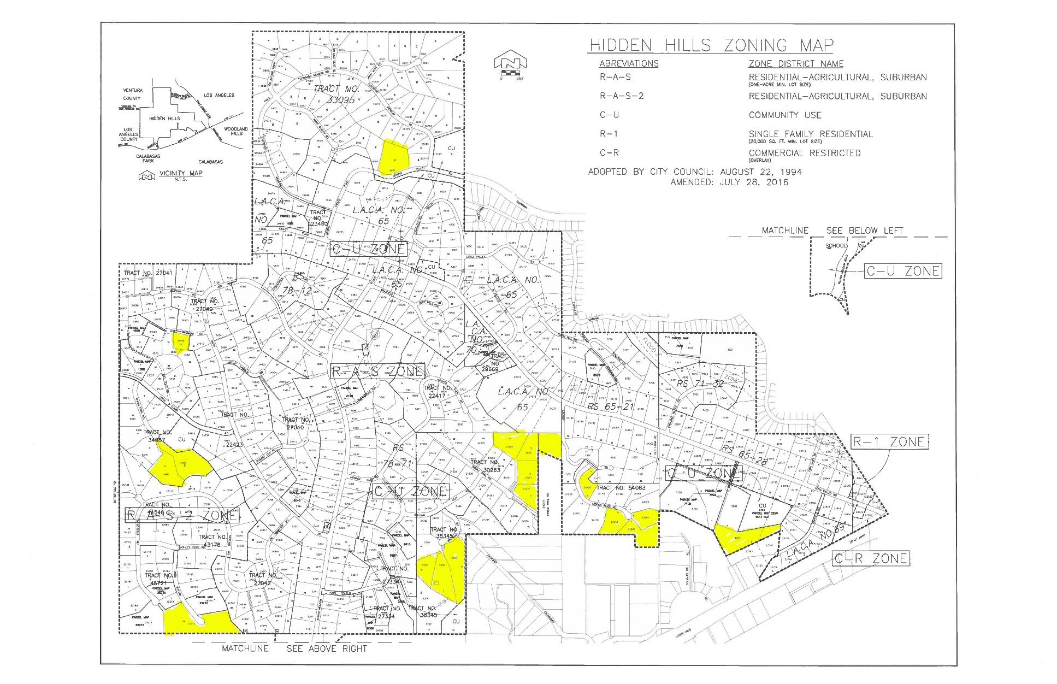
Table B-3
Affordable Housing Overlay Sites

Site Address | APN | Parcel Size (ac) | Existing Zoning | Existing Use | Lower | Mod | Above Mod | Total
23501 Long Valley Road | 2049-018-045 | 0.52 | CR (AHO) | Vacant
 | 2049-018-046 | 0.12 | CR (AHO) | Vacant
Subtotal |  | 0.64 |  |  | 12 |  |  | 12
23500 Long Valley Road | 2049-018-049 | 0.85 | CR (AHO) | Real estate office (approx. ½ of site is vacant) | 17 |  |  | 17
TOTALS |  | 1.49 |  |  | 29 |  |  | 29

Figure B-2
C-R Zone Sites Map
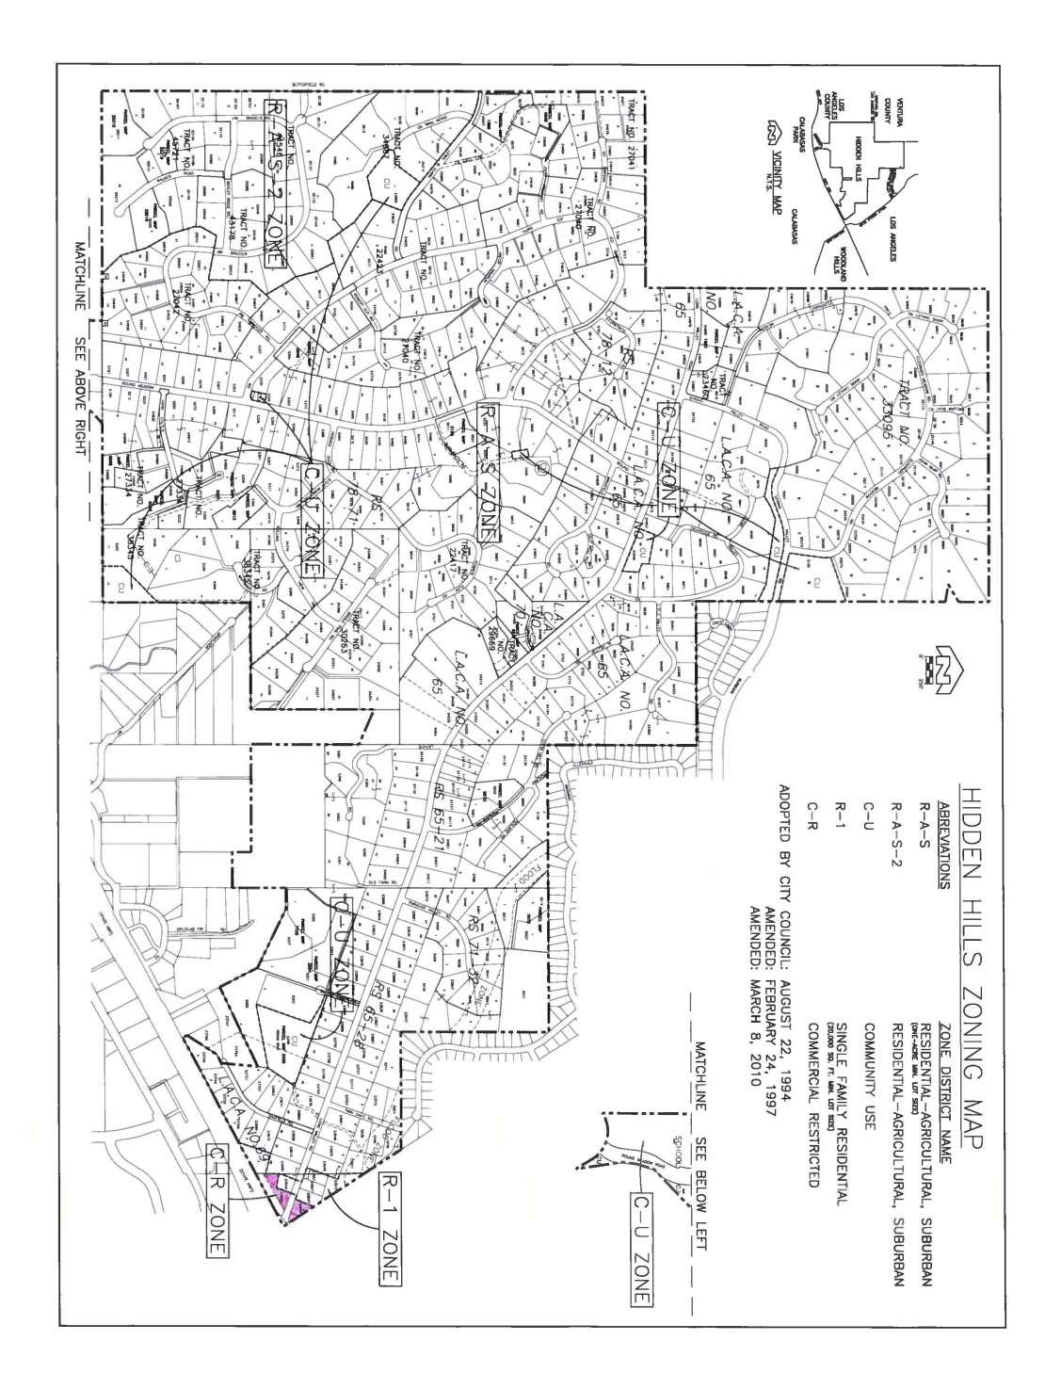

- Public Participation Summary

Section 65583(c)(5) of the Government Code states that “The local government shall make diligent effort to achieve public participation of all the economic segments of the community in the development of the housing element, and the program shall describe this effort.” Public participation played an important role in the formulation and refinement of the City’s housing goals and policies and in the development of a Land Use Plan which determines the extent and density of future residential development in the community.
City residents and other interested stakeholders had several opportunities to help identify needs, recommend strategies and provide comments on the draft Housing Element during its preparation. The City posted meeting notices, agendas, draft Housing Elements and related materials on the City website. A Housing Element FAQ was also prepared and posted on the website. The City compiled a notification list that included organizations representing the interests of lower-income households, persons with special needs, and fair housing (Table C-1).
An initial public study session was held by the City on ___________, 2021. The draft Housing Element was then prepared and posted for review on the City website on __________. The draft Housing Element was submitted to HCD for review on ______________.
After receiving comments from HCD, a revised draft element was prepared and posted for public review. The City Council held a noticed public hearing on ___________ to review HCD comments and the revised draft element, which was adopted and submitted to HCD for review. Public notice for all meetings was distributed to the interested parties listed in Table C-1. Table C-2 summarizes public comments that were received on the draft Housing Element.

Table C-1
Public Notice Interest List

SCAG  818 W Seventh St, 12th Floor  Los Angeles, CA 90017 |  | County of Los Angeles  Regional Planning Dept.  320 West Temple Street  Los Angeles, CA 90012 |  | Hidden Hills Community Assoc.  24549 Long Valley Road  Hidden Hills, CA 91302
City of Malibu  Planning Director  23825 Stuart Ranch Road  Malibu, CA 90265 |  | City of Calabasas  Planning Director  100 Civic Center Way  Calabasas, CA 91302 |  | City of Westlake Village  Planning Director  31200 Oak Crest Drive  Westlake Village, CA 91361
City of Agoura Hills  Planning Director  30001 Ladyface Court  Agoura Hills, CA 91301 |  | City of Los Angeles  Department of City Planning  200 N. Spring Street Rm. 525  Los Angeles, CA 90012 |  | So Cal Association of Non-Profit Housing  3345 Wilshire Blvd, Suite 1005  Los Angeles, CA 90010
AMCAL Multi-Housing, Inc.  30141 Agoura Rd, Suite 100  Agoura Hills, CA 91301 |  | LINC Housing  110 Pine Ave, Suite 500  Long Beach, CA 90802 |  | So Cal Housing Dev. Corp  9065 Haven Ave, Suite 100  Rancho Cucamonga, CA 91730
Habitat for Humanity  32904 Denver Springs Dr  Westlake Village, CA 91361 |  | Area Housing Authority  1400 W Hillcrest Dr  Thousand Oaks, CA 91362 |  | Jamboree Housing Corp.  17701 Cowan Ave, Suite 270  Irvine, CA 92614
Many Mansions  1459 Thousand Oaks Blvd #D  Thousand Oaks, CA 91362 |  | Las Virgenes Unified School Dist.  4111 N. Las Virgenes Road  Calabasas, CA 91302 |  | Las Virgenes MWD  Attn: Development Review  4232 Las Virgenes Road  Calabasas, CA 91302
Meta Housing  1640 S Sepulveda Blvd, Suite 425  Los Angeles, CA 90025 |  | San Fernando Valley Fair Housing Council  14621 Titus St #100  Panorama City, CA 91402  info@fhcsfv.com |  | North Los Angeles County Regional Center  9200 Oakdale Ave., Suite 100  Chatsworth, California 91311

Table C-2
Summary of Public Comments
Comment | Response

This page intentionally left blank.

HCD memo of 4/18/07 (http://www.hcd.ca.gov/hpd/hrc/rep/state/inc2k7.pdf)
www.nlacrc.org
Stewart B. McKinney Act, 42 U.S.C. §11301, et seq. (1994)
Sources: California Housing Partnership Corp; City of Hidden Hills, 2021
Health and Safety Code Section 17021.5
City of Hidden Hills Planning Department, October 2013
https://scag.ca.gov/sites/main/files/file-attachments/adu_affordability_analysis_120120v2.pdf?1606868527

